Graphical Budget Planner 1.1.5
User Manual

version 2024.07.12

Table of Contents
1. Table of Contents 2
2. License, Disclaimers and Source Code Repository 5
3. Supported Platforms & Languages, Requirements 6
4. Installation 7
4.1 Linux Platforms 7
4.1.1 Ubuntu Special Case 7
4.2 Windows® OS 7
5. Known Issues 8
6. Introduction 9
6.1 Overview 9
6.2 Incomes/Expenses Definitions 10
6.2.1 Periodic Stream Definition 10
6.2.2 Irregular Stream Definition 11
6.3 Growth for Incomes/Expenses 11
6.4 Scenario 12
6.5 Cash Balance Curve 12
6.6 Analysis 14
7. User Interface Description 16
7.1 Main Window 16
7.1.1 Cash Balance Curve : 17
7.1.2 Toolbar buttons 17
7.1.2.1 1M to 25Y toolbar buttons 17
7.1.2.2 “Max” toolbar button 18
7.1.2.3 “Fit” toolbar button 18
7.1.2.4 “Custom” toolbar button 18
7.1.2.5 Panning buttons 18
7.1.3 Action Zone for the Chart 18
7.1.3.1 Start Amount 18
7.1.3.2 Show Points 19
7.1.3.3 CSV Export 19
7.1.4 Selected Point Info Panel 19
7.1.4.1 Date : 20
7.1.4.2 Amount : 20
7.1.4.3 Change : 20
7.1.4.4 Financial Events Listbox Content: 20
7.1.5 Date Range 20
7.2 Create New Scenario Windows 20
7.2.1 First step : Choose a currency 20
7.2.2 Second Step : Edit the scenario 21
7.3 Edit Scenario Window 21
7.3.1 Metadata Editing 21
7.3.1.1 Name 22
7.3.1.2 Description 22
7.3.1.3 Annual Inflation 22
7.3.2 Financial Stream Definitions Editing 23
7.3.2.1 Incomes / Expenses Selector 24
7.3.2.2 Filters 24
7.3.2.3 Financial Stream Definitions List 24
7.3.2.4 Action Buttons 25
7.3.3 Applying the modifications 25
7.4 Creating/Editing a Periodic Stream Definition 25
7.4.1 Name 26
7.4.2 Description 26
7.4.3 Amount 26
7.4.4 Period and Period Multiplier 26
7.4.5 Validity Range 26
7.4.6 Monthly Growth 27
7.4.7 Colorize Name 27
7.4.8 Growth Application Period 28
7.4.9 Enabled 30
7.4.10 See All Occurrences 30
7.5 Creating/Editing an Irregular Stream Definition 30
7.5.1 Name 31
7.5.2 Description 31
7.5.3 Colorize Name 31
7.5.4 Enabled 31
7.5.5 List of Occurrences 31
7.5.6 Actions Buttons 31
7.5.7 Load From File 31
7.6 Options Window 32
7.6.1 Category “General” 33
7.6.1.1 Scenario – No of years calculated 33
7.6.1.2 How date of “today” is obtained 33
7.6.1.3 Application Font 34
7.6.1.4 Allow colorization of Incomes/expense names 34
7.6.1.5 Exported text – Amount are localized 34
7.6.2 Category “Charts” 34
7.6.2.1 Use Dark Mode 35
7.6.2.2 Dark Mode Curve Color 37
7.6.2.3 Light Mode Curve Color 37
7.6.2.4 Overscaling for main chart 37
7.7 Analysis Window 38
7.7.1 Relative Weight Tab 38
7.7.1.1 Parameters Zone 39
7.7.1.2 Result Chart 40
7.7.1.3 Exporting to Image File 40
7.7.2 Monthly Report - Chart 40
7.7.2.1 Parameters Zone 40
7.7.2.2 Result Chart 41
7.7.2.3 Panning Controls Zone 42
7.7.3 Annual Report – Chart 42
7.7.4 Monthly Report – Table 42
7.7.4.1 Convert to Present Values 42
7.7.4.2 Export To CSV 43
7.7.5 Annual Report - Table 43
8. Usage 44
8.1 Preparing to create a budget 44
8.1.1 Collecting Information 44
8.1.2 Modeling Inflation that Varies Through the Months and Years 44
8.1.3 Practical Examples of Periodic Incomes/Expenses 45
8.1.3.1 Salary Received Every 2 Weeks, No Growth 45
8.1.3.2 Salary Received Twice a Month (15th , End of Month), No Growth 46
8.1.3.3 An Annual Rent with Fixed Monthly Payment 46
8.1.3.4 Weekly Grocery Bill that Follows Scenario’s Inflation 47
8.1.3.5 Monthly Loan Payment at Each End-Of-Month 48
8.1.3.6 Monthly Car Maintenance That Increases By a Variable Amount 49
8.1.4 Practical Examples of Irregular Incomes/Expenses 51
8.1.4.1 One-time Tax Return 51
8.1.4.2 Irregular Incomes from Selling Goods 51
8.1.4.3 Periodic Expenses but Irregular Amounts 52
8.1.4.4 Importing a Complex Set of Incomes 53
8.2 Creating the Budget in GBP 54
8.3 Using a Budget Scenario Over Time 54
8.3.1 Typical Workflow 54
8.3.1.1 Set “Start Amount for Today” Value 55
8.3.1.2 Inspect the Cash Balance Curve and Analysis Module 55
8.3.1.3 Play with the Scenario Data and Look at the Results 56
8.3.1.4 Improve Readability Using Colorization of Name 56
8.3.2 Alternate Workflow 57
8.3.2.1 What Is the Alternate Workflow ? 57
8.3.2.2 When Can this Alternate Workflow Be Useful ? 58
9. Logs 59
9.1 Format and Location 59
9.2 Example 60

License, Disclaimers and Source Code Repository
Graphical Budget Planner (a.k.a graphical-budget-planner or GBP or gbp) is a free and open source Qt desktop application intended to ease significantly the process of creating, maintaining and analyzing a personal budget.

This application and all its source code are licensed under the GNU Affero General Public License version 3 or later (AGPL-3.0-or-later). It's Free Software. See https://www.gnu.org/licenses/#AGPL/

Software repository for GBP can be found at :

https://codeberg.org/claude_dumas/gbp

Being built with the Qt 6.2.4 toolkit, GBP is subject to the Qt terms and conditions : see qt.io/licensing

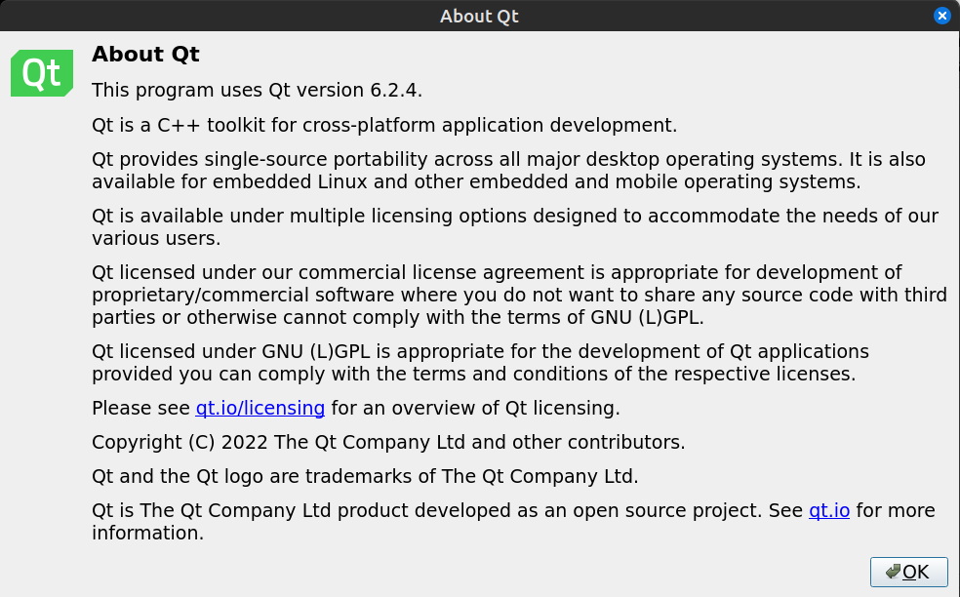

Credits :
- Tobias Leupold : code to calculate difference between 2 dates -> see https://nasauber.de/blog/2019/calculating-the-difference-between-two-qdates/
- QCustomPlot : A Qt C++ widget for plotting and data visualization -> see https://www.qcustomplot.com/

Any feedback relating to this documentation can be provided by creating a ticket or a pull request against this repository.

This documentation is released under the GPL 3.0 license

Supported Platforms & Languages, Requirements
GBP is intended to be run first and foremost on the Linux Operating System (for example Ubuntu, Linux Mint, Fedora, OpenSUSE, Arch, Manjaro, MX Linux, etc). But since it is built using the Qt cross platform toolkit, a version of GBP for the Windows® Operating System have also been produced. Tests have been conducted on Windows® 10 only.

GBP does not use a lot of RAM (the absolute worst case ever seen is 175 MB for an extremely demanding testing scenario) and necessitate roughly 50 MB of disk space (not taken into account the scenario files that you will create and GBP log files, which are all pretty small anyways).

As of July 2024, GBP has been successfully tested on the following Linux platforms :
- Ubuntu 24.04, Gnome, both X11 and Wayland, kernel 6.8.0
- Ubuntu 22.04.4, Gnome 42.9 both X11 and Wayland, kernel 6.5.0-21
- OpenSUSE Leap 15.5, KDE Plasma 5.27.9 both X11 and Wayland, kernel 5.14.21
- Mint 21.3 Edge X11
- Mint 21.3 X11 Kernel 5.15
- Debian 12.5 , Plasma-X11, KDE 5.27.5 qt 5.15.18 kernel 6.1.0.21
- Debian 12.5, Plasma-Wayland, KDE 5.27.5 qt 5.15.18 kernel 6.1.0.18
- Debian 12.5, XFCE 4.18, qt 5.15.18 kernel 6.1.0.18
- Debian 12.5, Gnome classic on Xorg, qt 5.15.18 kernel 6.1.0.18
- LMDE 5, X11, kernel 5.10.0, Cinnamon 5.6.8
- LMDE 6 X11, Cinnamon 6.04, kernel 6.1.0-17
- Fedora 39 , Gnome, both X11 and Wayland, kernel 6.9.4
- Fedora 40, KDE Plasma 6.1.1, Wayland, Kernel 6.9.5
- MX linux 23.2 XFCE 4.18.1 (Debian 12.4) kernel 6.6.12
- MX linux 23.2 KDE Plasma, both X11 and Wayland, kernel 6.6.12
- Manjaro Plasma, KDE Plasma 6.0.5, both X11 and Wayland, Qt 6.7.1, Kernel 6.6.32

GBP supports English and French languages. By default, English is used, but if the host Operating System is in French (whatever the country), then GBP will switch to French. More languages will hopefully be added in the future, if resources to translate are available.

A mouse is required to use the software.

Installation

Linux Platforms
GBP is distributed as an “AppImage”, which is a single-file executable packaging format allowing a program to run on many Linux distributions. There is nothing else to install. After downloading the AppImage from GBP site, user just has to enable “executable” permission on the file and it is ready to be launched. For example, on Linux Mint, using the “properties” menu of the file :

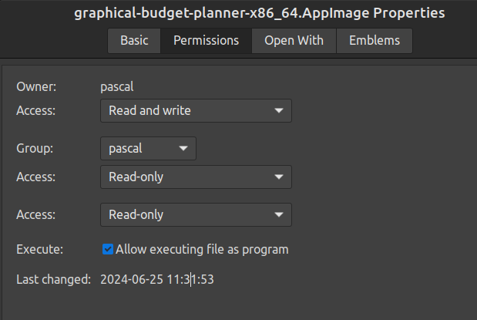

Ubuntu Special Case
On Ubuntu (tested on v 20.04, 22.04, 24.04), additional steps must be performed. In order to run an AppImage, some packages are missing from the default distribution. Ubuntu needs the FUSE library to run AppImage like GBP. Otherwise, when launched, you will get the following error :

dlopen(): error loading libfuse.so.2

AppImages require FUSE to run. To solve this, do :

sudo apt install libfuse2

Windows® OS
GBP is distributed as a simple zip file : unzip it in a folder of your choice and run the gbp.exe application.

Known Issues
- On Linux Gnome, system’s theme is not properly respected by GBP. Whether you select Light or Dark Theme, the application foreground and background colors will not changed for GBP (this is due to some conflicts between GTK and Qt 6).
- Sometimes the X axis of the main graph shows discontinuities, like this.
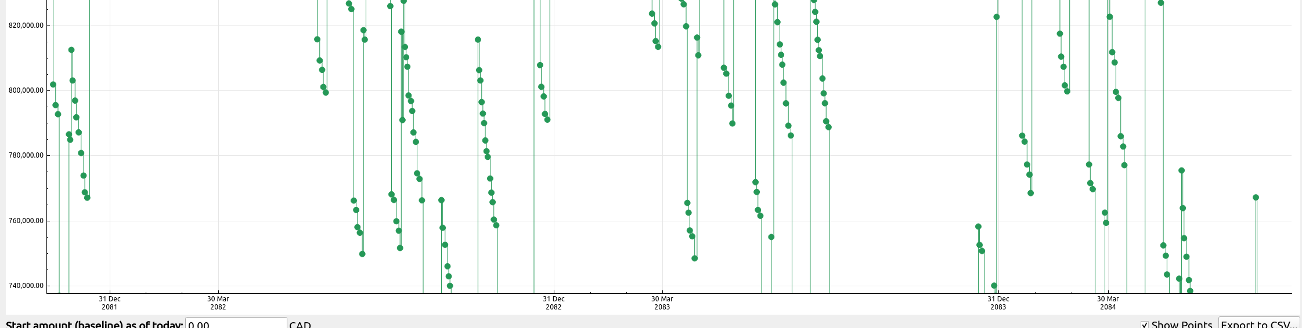
It is believed to be a bug in QcustomPlot library used by GBP and we are working with the developer to identify the cause.

Introduction
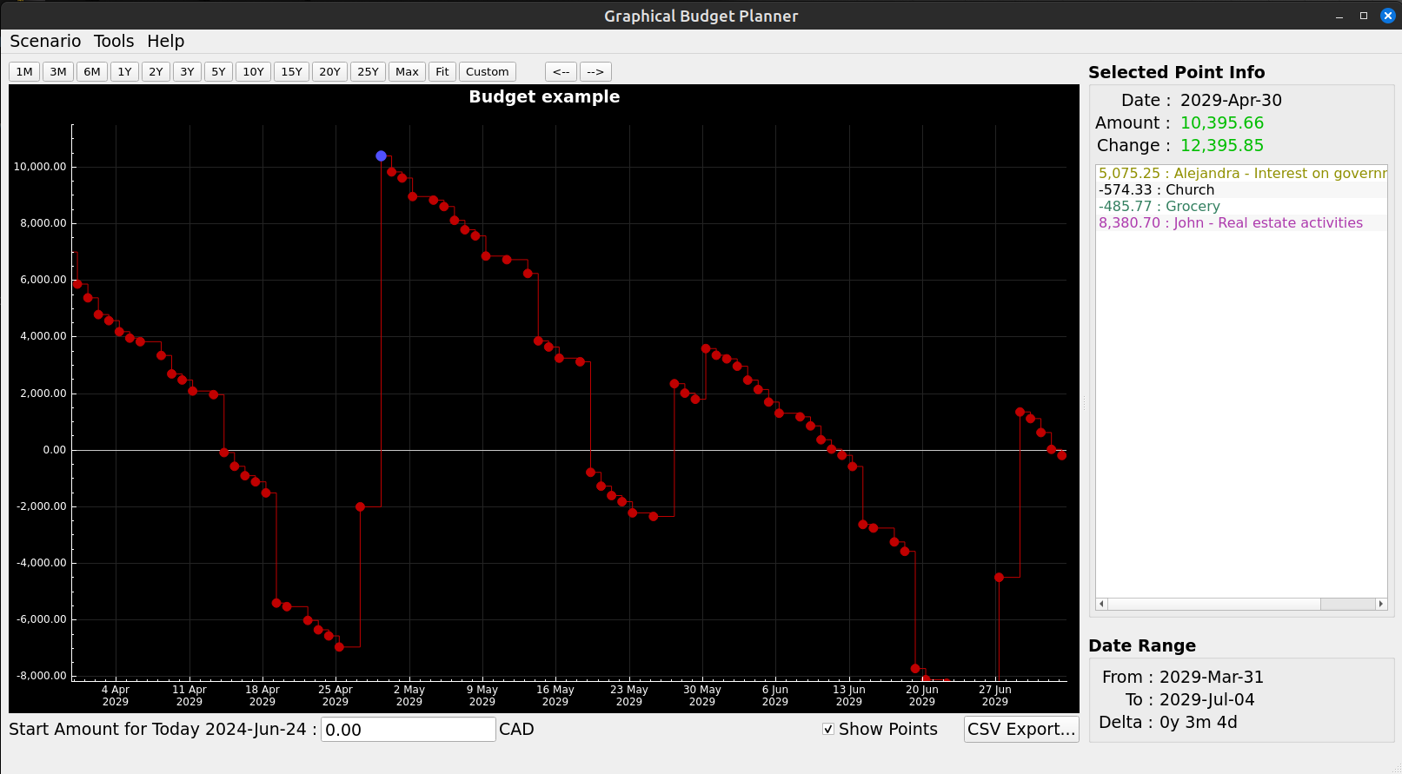

Overview
Graphical Budget Planner (GBP) is an open source Qt desktop application intended to ease significantly the process of creating and maintaining a personal budget. It allows the following :

- See graphically the evolution of your cash balance through time, at any given moment in a period covering the next 100 years !
- Easy zooming and/or panning
- Specify painlessly all your forecasted income/expense budget items, with flexibility to define periodic or irregular flow of incomes/expenses.
- Optionally define inflation, either as a constant value or a complex series of changing values.
- Optionally define a custom monthly growth pattern for any income/expense specification , expressed either as a constant value or a complex series of changing values.
- Perform automatically different types of analysis on your data, like relative weight of incomes/expenses over custom period, monthly and yearly reports.
- Your data is not locked in : all scenarios are in open JSON format, and resulting data are exportable in CSV format.
- Fully support UNICODE in all text fields.

GBP is all about CASH BALANCE FORECASTING : the key principle adopted in the design of the software is to take into consideration only the FUTURE incomes/expenses expected to occur, starting “tomorrow”, “today” being the system date when the application starts. Consequently, this is not the right tool if you want know how and when your money has been spent in the past (that is "before today"). That also means that if you start the program, lets say once a month, you may not see the same curve in the Main Window each month. This is because events that have occurred during a given month are now past when the next month occurs and thus not taken into consideration. There is however a way in the Options Settings to overcome this behavior (see “Settings).

Incomes/Expenses Definitions
In GBP, basically, you have to define all the expected/forecasted incomes and expenses of the future, in order to see the evolution of the cash balance in the curve shown in the Main Window. So another key concept is the notion of Income/Expense “Definition”, also known as “Financial Event Stream Definition” (or just “Financial Stream Definition” to make it short), because it is these definitions that will create in time a flow of financial events that will be either incomes or expenses. Said differently, it’s a declarative specification created by the user and that states how an associated flow of money (the financial event “stream”) is generated through time . An example of a Financial Stream Definition is a salary. Each occurrence of money coming from the definition is called a “financial event” (e.g. the salary occurrence of 2000$ on Feb 3, 2030 is a “financial event”. Another occurence on Mrs 3, 2030 is another financial event).

They are 2 types of Financial Stream Definition :

Periodic Stream Definition
It defines a fixed amount of money (income or expense) that occurs at regular intervals in time. The interval is specified by first defining a period type :
- Year
- Month
- End-of-month
- Week
- Day
And then a “period multiplier”, which is an integer that is a multiplication factor of the period type selected (e.g. 3 years or 12 weeks).

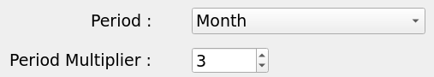
A Periodic Stream Definition is also bounded by a “validity interval”, which is the period of time within which the financial events will be generated for that Periodic Stream Definition.

An example of a Periodic Income would be a dividend received every 3 months or a salary received every 2 weeks. A validity interval of [1 Jan 2000 – 4 Feb 2020] means that the first amount will be generated on 1 Jan 2000 and the last one cannot go over 4 Feb 2020.

Irregular Stream Definition
This is a set of income or expense events that occur at very specific moments, as chosen by the user. The amounts can be completely different for each element in the set. There is no special constraints governing when such events can occur : it can be periodic or not. Hence the name “irregular” for that type of Stream Definition. An example of an Irregular income could be a set of incomes received from selling some art paintings. In that case, it is clearly not periodic :
- 1 Feb 2024 : $300
- 23 Mar 2025 : $1800
- 12 Sep 2026 : $3200
Another example of an irregular income could be a periodic revenue stream from complex financial instruments (e.g. dividends from multiple stocks) calculated outside GBP and imported : the values change every month and thus cannot be simply modeled with a “Periodic Income” with constant values or deterministic growth pattern.

Growth for Incomes/Expenses
For a Periodic Stream Definition, it is possible to define a “Growth Pattern” that allows the initial fixed amount to actually change in time. There are 4 different ways to specify this grow pattern :

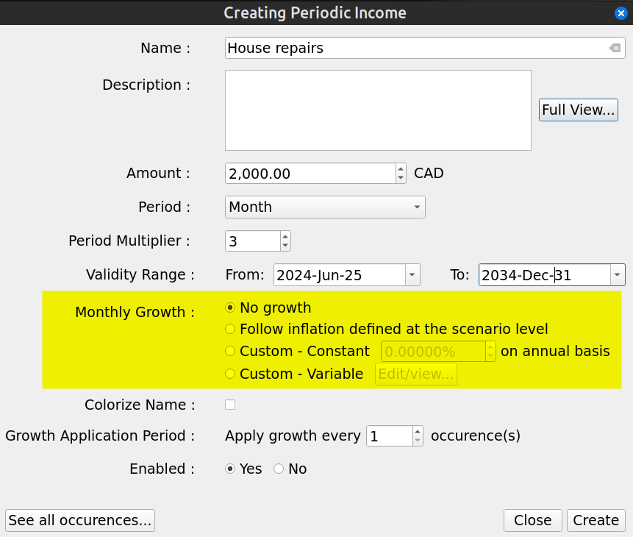
- “No growth” : The initial amount stays constant for the whole validity range
- “Follow inflation” : Growth is exactly identical to the inflation pattern defined in the scenario
- “Custom – constant” : Specify a constant growth, that applies only to this Periodic Stream Definition
- “Custom - Variable” : Specify a variable growth pattern, that applies only to this Periodic Stream Definition

Scenario
In GBP, a scenario is a set of Financial Stream Definitions, plus other miscellaneous metadata.

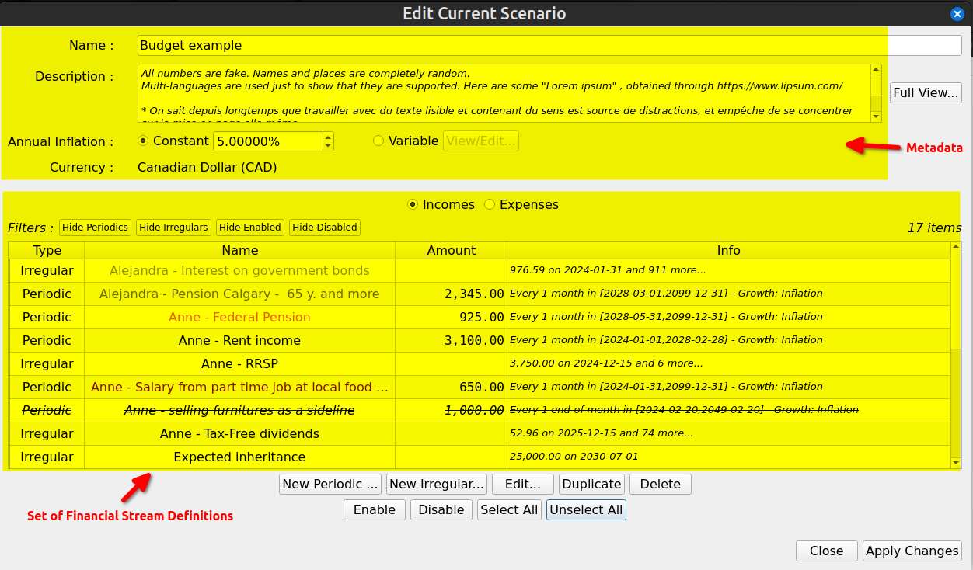
All this information is stored in a single file called a “scenario”. On disk, you may have as many scenarios as you want and they may be stored anywhere you like : there are just ordinary files (JSON format). There is only one scenario at a time that can be loaded in GBP. Once loaded via the “Scenario→Open” or “Scenario→Open Recent”, scenario’s data can be inspected or edited using the “Scenario->Edit” menu. Any change made must be saved on disk for it to become permanent, through the “Scenario->Save” or “Scenario→Save As” menu.

Cash Balance Curve
Once a scenario is loaded, in the Main Window, the resulting “cashflow balance” curve will be shown, which is the result of all the incomes/expenses events occurring through time, as determined by their definitions.

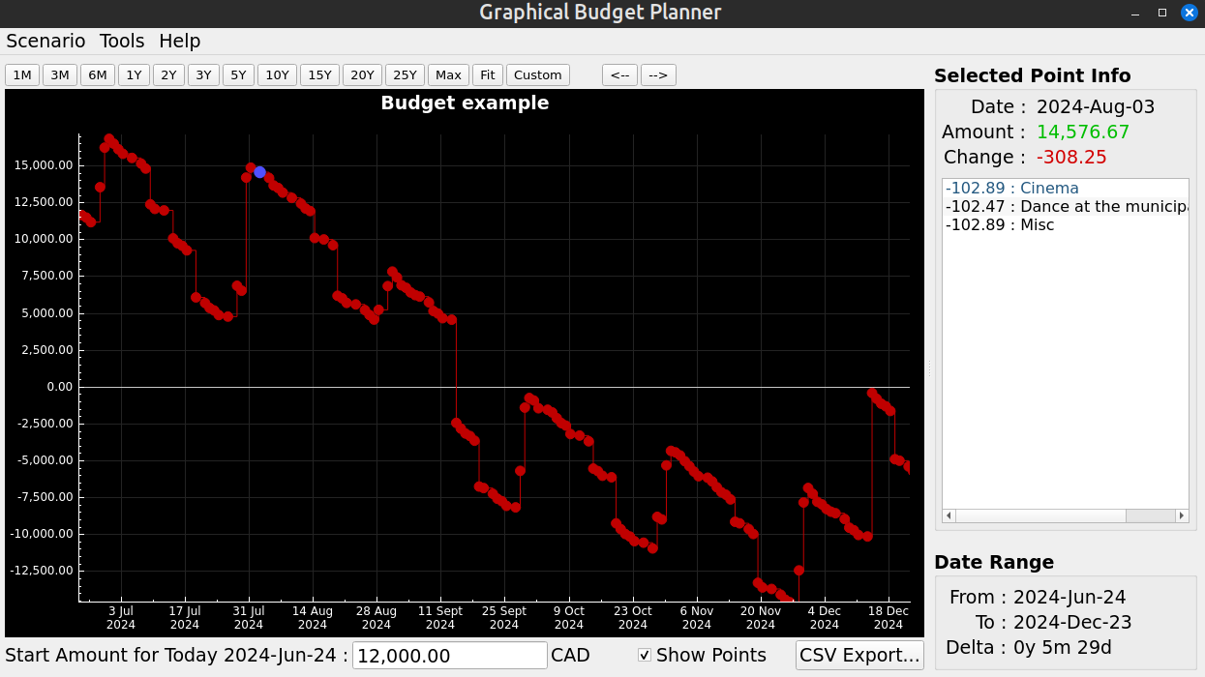
You can zoom the curve or move it with the mouse :
- Zoom / unzoom : middle-mouse wheel
- Move : left-click & hold, then move mouse or use the “←” or “→” buttons in the upper toolbar
- Set predefined Time Interval : use the predefined buttons in the upper toolbar

Each data point shown (the small disk on the chart)

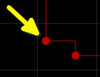
represents an amount which is the sum of :
- all the financial events amount that occurred in a that day
- the final cash balance of the previous day.
If you click on a point, the color of the point changes to Blue

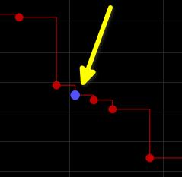
and the “Selected Point Info” panel to the right will show the details :
- Date : date of occurrence for that point
- Amount : total cash balance for that day, taking into account all the daily financial events
- Change : change in cash balance from the previous occurrence

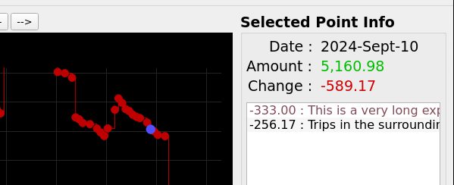
Unclicking the point or clicking not on a point clears this panel.

Analysis
GBP provides an “analysis” module in order to provide a more in depth insight of the data generated from the scenario’s Financial Stream Definitions. More specifically :

=> A pie chart that illustrates the relative weight of each income (or expense). Very useful to understand what are the most important incomes or expenses over a specific time interval.

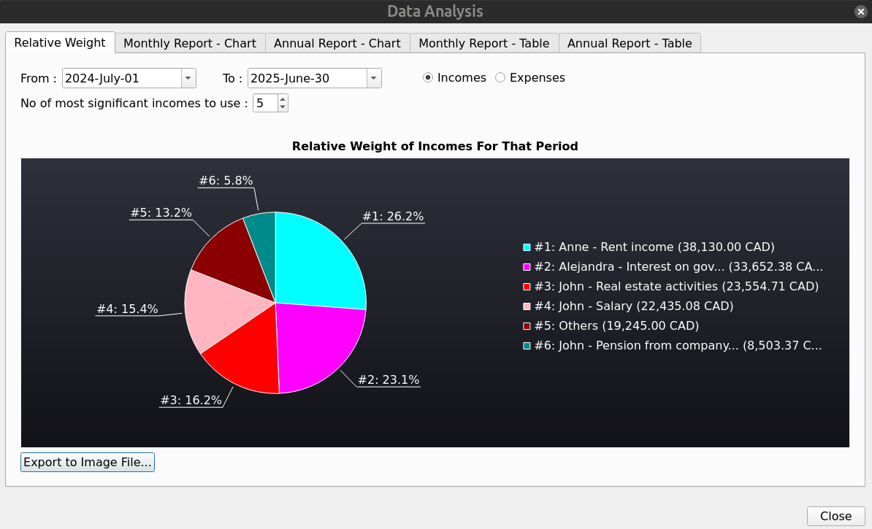

=> A bar chart showing the monthly/yearly total for incomes (or expenses)

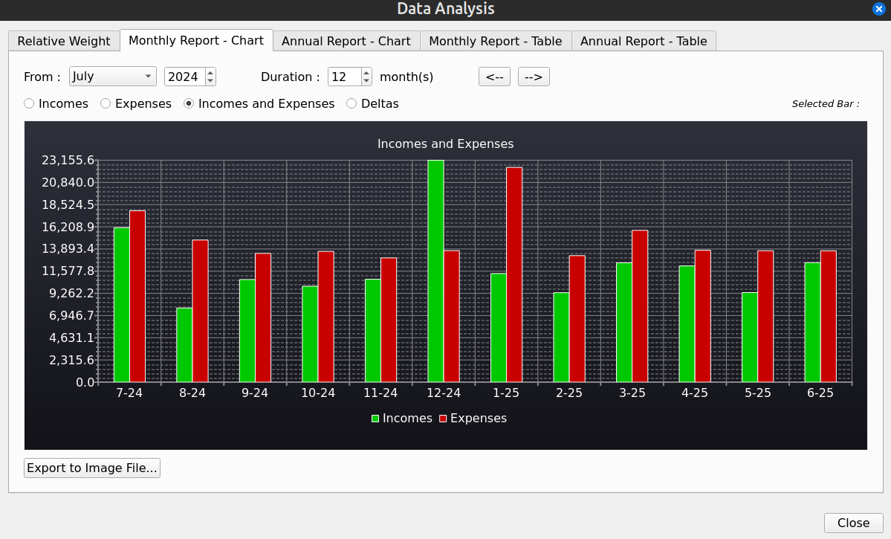
=> A tabular form of the previous

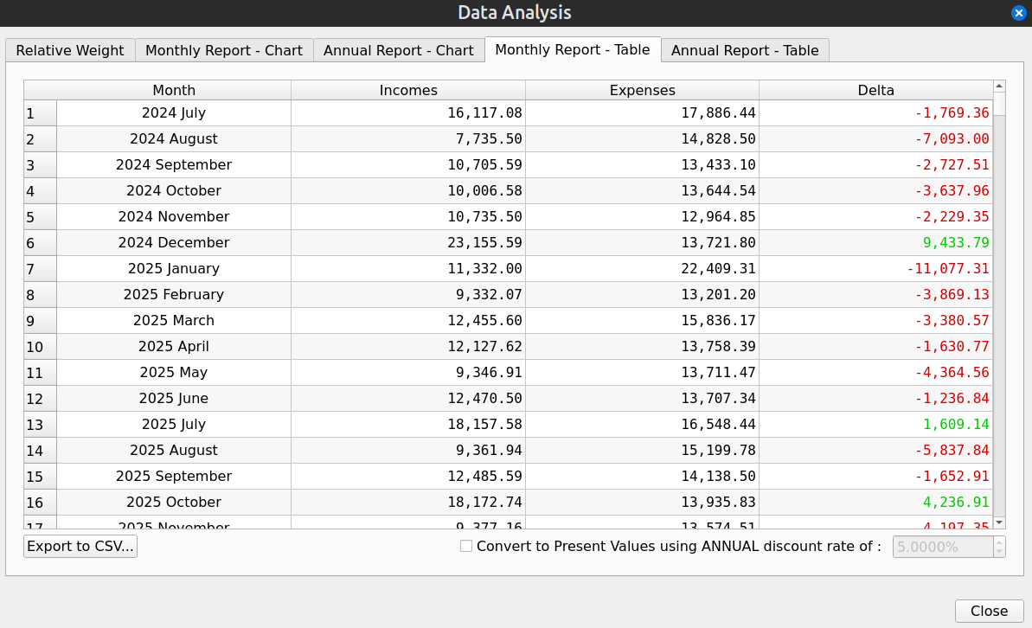

User Interface Description

Main Window

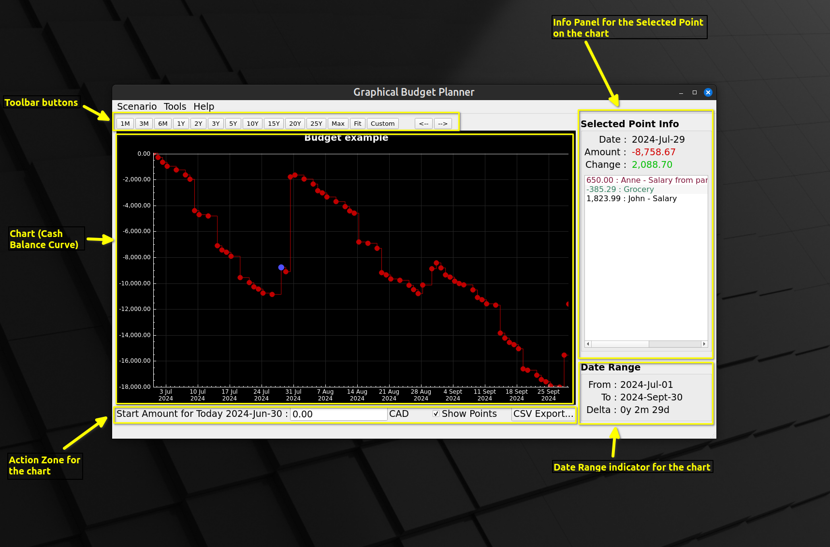
This is the first window displayed by GBP after being launched.

Note that user can increase/decrease the size of the right part of the Main Window using the “splitter” control found between the 2 “left” and “right” regions : just click on the yellow region identified in the figure below and move the mouse while still pressing on mouse button.

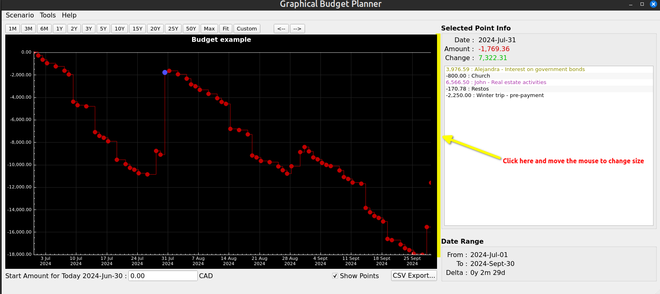
The different areas of the Main Window are described bellow :

Cash Balance Curve :
This curve shows a series of point, each one being for a specific distinct day where at least one financial event occurred. There can be no point for a day where no financial event happened. The amount associated to a point is the “final daily amount” for that day, that is the sum of :
- All financial events having occurred during that day
- The final amount for the previous point

The X axis shows the current time interval and the Y axis the amount values.

Toolbar buttons
This area is made of 2 zones :
- the predefined range buttons (to the left)
- the panning buttons (to the right)

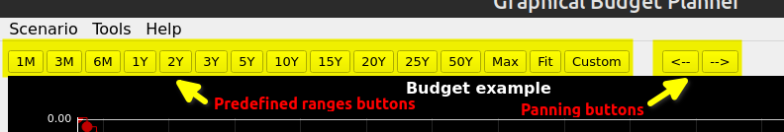

1M to 25Y toolbar buttons
These buttons will rescale the chart for a predefined time interval range, starting at the date of “tomorrow”. “M” stands for “month(s)”, “Y” for “year(s)”

“Max” toolbar button
Rescale the chart so that the full X range is shown (“tomorrow” to last date of the calculated data). The last date of the calculated data is determined by the option “Scenario – No of years calculated” in the Option Dialog.

“Fit” toolbar button
Like “Max”, but also rescale the Y axis, so that the min/max values are visible.

“Custom” toolbar button
Allow the user to enter its own X axis range. The start of the X axis can then be different than “tomorrow”.

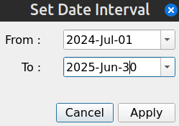

Panning buttons
These buttons allows to move the chart to the left or to the right, by approximately the same time amount of time than the current time interval displayed.

Action Zone for the Chart
This area contains controls that may alter the chart content or appearance, or allow exporting the data to a CSV file.

Start Amount
This features adds a “baseline” amount to the chart, which corresponds to the current starting amount before any financial events occurred. In other words, this is your current cash balance as of today. It is NOT part of the scenario and thus is NOT saved on disk. It has to be re-entered each time GBP is started, but this is the whole point...It represents the available amount of cash for the user as of “today”. All the financial events will occurred from “tomorrow” and add/subtract to this initial amount. See “Usage” for more information about how to use it.

There is an option to set the value of “today” not to the system’s date at launch time (which is the default), but to an arbitrary value. See Options Dialog.

Show Points
When OFF, the chart will not show the colored disk around the chart’s points. This is useful if there is a huge number of points and one want to see the overall shape of the curve.

CSV Export
Allow to export ALL curve’s data points to a CSV file for futher processing by other tools (like Libre Calc). The user selects a file name : by default, a .csv extension is added if the file name does not contains one, otherwise it uses what the user has entered.

The first line of the file is a header, with fields separated by a TAB character :

Date Total Daily Incomes Total Daily Expenses Total Delta Cumulative Total

with the following semantic for the columns :
- Date : Date for this data point (format = YYYY-MM-DD)
- Total Daily Incomes : The total amount of all the incomes that occurred during that day
- Total Daily Expenses : The total amount of all the expenses that occurred during that day
- Total Delta : Total Daily Incomes - Total Daily Expenses
- Cumulative Total : The final amount at the end of the day (cash balance)

The rest of the file contains the data points info (one line per data point), like for example

2024-07-01 3100.00 -3031.29 68.71 20068.71
2024-07-02 0.00 -333.00 -333.00 19735.71
2024-07-03 0.00 -375.02 -375.02 19360.69
2024-07-04 0.00 -310.60 -310.60 19050.09
2024-07-06 0.00 -281.79 -281.79 18768.30

where fields are separated by a TAB character.

By default, amounts are written in the form

Thousands separator : none
Decimal separator : ‘.’

but it is possible to generate a localized version : see Options Dialog

Selected Point Info Panel
Provides information for the selected point on the chart.

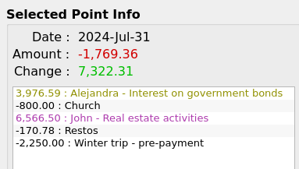

Date :
Date of the data point. Format is YYYY-MMM-DD

Amount :
Final Daily amount, taking into account all the financial events of the day. The amount is green if >=0, red otherwise

Change :
Total of all the incomes of the day minus total of all expenses of the day. The amount is green if >=0, red otherwise

Financial Events Listbox Content:
This is the list of all financial events that occurred during the day. It is sorted by Financial Stream Definition name (sorting takes into account the Locale defined on the user’s computer).
Expenses are number < 0. Financial Event name is colorized if defined so.

Date Range
Shows the time interval (X axis) currently used by the chart. Real-time refreshed when zooming or panning occurs.

Create New Scenario Windows
Accessed with the “Scenario→New” menu. This is used to create a new scenario. To save it, use the “File→Save” or “File→Save As” menu.

First step : Choose a currency
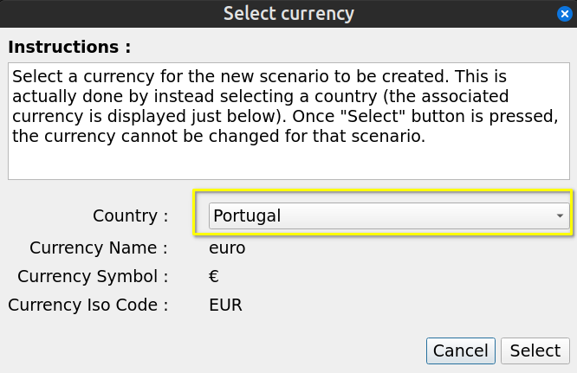
When a scenario is created, the first thing to do is to select a currency to be associated to it. This is required because it defines how many decimal units the amount shown will have (e.g. Yen has 0 decimal, Euro has 2). But it is easier to select a country instead, since there is a 1-to-1 relationship between both. The country must be chosen with the “Country” combobox (in yellow in the figure above).
Once selected, a currency cannot be changed for a given scenario.

Second Step : Edit the scenario
See “Edit Scenario Dialog”. It is the same content and behavior, except for 2 things :
- When pressing the “Create Scenario” button, the Create Scenario dialog will disappear.
- Pressing “Cancel” will cancel the process of a creating new scenario : the currently loaded scenario is kept loaded.

Edit Scenario Window
Accessed with the “Scenario→Edit” or “Scenario→Recent” menu. This window is intended to view and/or change the content of an existing scenario. Changes are NOT saved in the scenario file on disk until you select “File→Save” or “File→Save As” menu.

This window is not modal (the only one in GBP), meaning that its content can be edited while still having access to the Main Window that shows the charts. This is on purpose and intended to ease and accelerate the work on a scenario. A typical use is to have the Main Window maximized on a monitor and the Edit Scenario window shown on another monitor. This way, change in parameters can be seen immediately in the Main Window, allowing for example zooming and panning.

All changes made to a scenario can be committed for the update of the cash balance curve by pressing the “Apply” button. Again, this does NOT save the data on disk.

Metadata Editing
Metadata are located at the top half area of the Edit Scenario window :
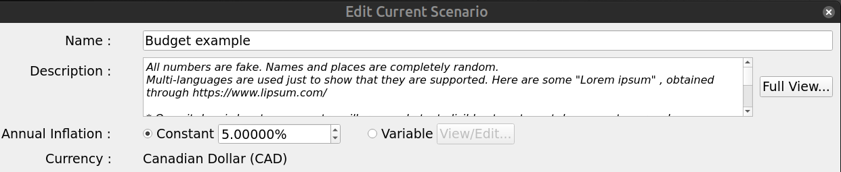

Name
Just enter the new name in the right field. There is a limit of 100 characters for the name. This is NOT the name of the scenario file on disk !

Description
User’s notes about the scenario. An be up to 4000 characters. Click “Full View” to edit the Description in a much bigger window.

Annual Inflation
A growth pattern specific to this scenario and used to define an inflation value that may affect all incomes/expenses (increase or decrease their values, depending on the inflation value). Inflation is made available to all Financial Stream Definitions to be used or not (this is optional).

Constant :
A constant growth value ranging from -100% to 10000%. It stays the same in past, present, future. This is an ANNUAL value, but it is the equivalent monthly growth value that is actually applied on a monthly basis on the 1st of each month.

Variable :
A variable growth pattern : this is for advanced use. It can be used to define a complex and changing growth pattern for inflation.
It consists of a list of (month date, annual inflation value) "pairs", each defining a new inflation value to be applied from this date, until a new pair is defined or otherwise for ever. Before the first pair is defined, inflation value is 0. Each time a new pair is defined, a new inflation value becomes in force from that date. Inflation is always applied on the first day of each month.

For example, lets say we have the following pairs defined :
(1 jan 2000, 10%) , (1 jan 2002, -10%)
Here are the values of an amount of 1000 that starts existing on 1 jan 1998 and is submitted to this growth pattern:
- 1 jan 1999 : 1000 (growth = 0%)
- 1 jan 2000 : 1100 (new growth value=10%,)
- 1 jan 2001 : 1210 (growth value still at 10%)
- 1 jan 2002 : 1089 (new growth value=-10%)
- 1 jan 2003 : 980.10 (growth still at -10%, for ever)
If the amount of 1000 starts existing on 1 jan 2003, then we have
- 1 jan 2003 : 1000 (no growth applied on the first occurence)
- 1 jan 2004 : 900 (growth is -10% as lastly defined in 1 jan 2002)
- 1 jan 2005 : 810 (growth is -10% as lastly defined in 1 jan 2002)

Here is what looks like the definition of variable inflation (values different from above) :

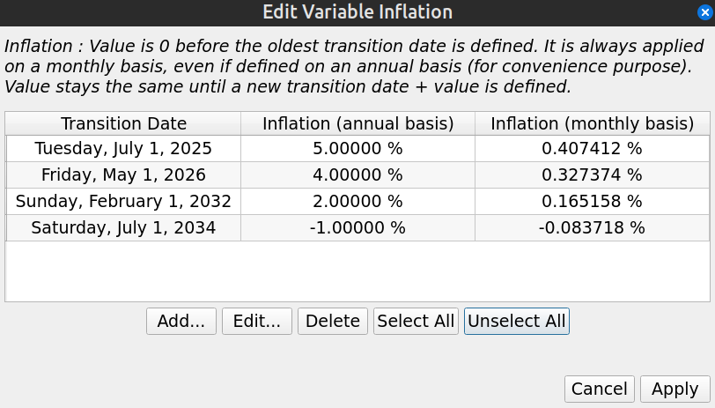
The buttons “Add”, “Edit”, “Delete” at the bottom are to change the list of “pairs”. a.k.a “transition points”. Note that “Delete” remove all the selected rows. The “Add” button pops up the following Window :

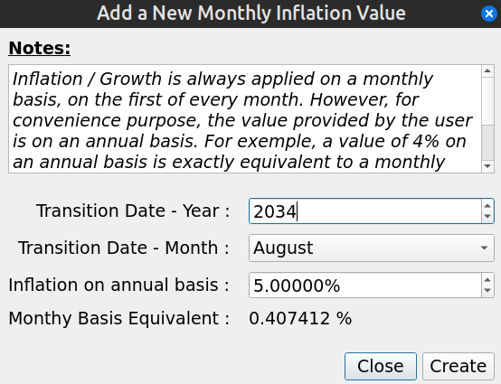
When adding a new “transition point” (date + inflation value), the value entered is always on an Annual Basis, but as mentioned before, it is actually the equivalent Monthly Basis that is used internally and applied every month on the 1st. This is why is shown the “Monthly Basis Equivalent” at the bottom. Note that you cannot create a new “transition point” with a date that already exists.

Editing a “transition point” uses essentially the same Dialog. One notable difference is that if you enter a date that already exists, it will be accepted and the new value of inflation replaces the old one for that date.

Financial Stream Definitions Editing
There are 4 zones in this part of the Edit Scenario Dialog (middle section of the window) :

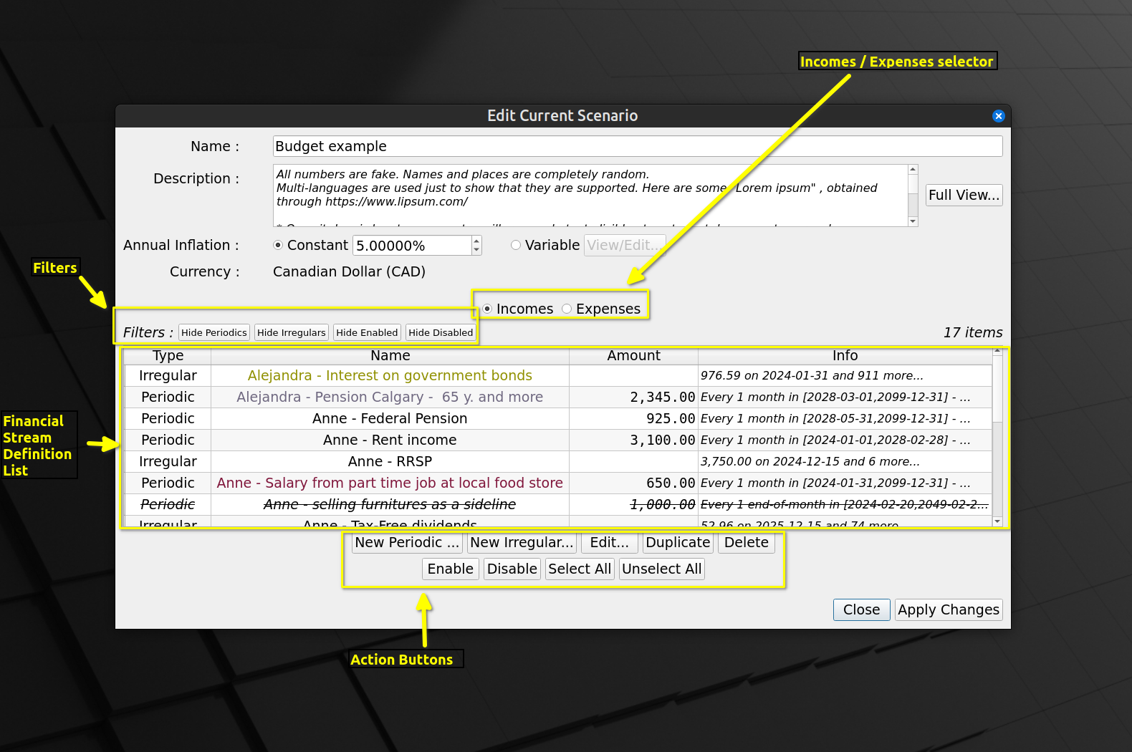

Incomes / Expenses Selector
Specifies if the Financial Stream Definitions List will contains either Incomes or Expenses (cannot have both).

Filters
Allows hiding some Financial Stream Definitions in the list. Press on (toggle) any of the 4 buttons to activate or deactivate the corresponding filter. This is just for visualization purpose : hidden items are STILL taken into account to create the chart of the main window.

Financial Stream Definitions List
List some properties of the Financial Stream Definitions contained in the scenario (either Incomes or Expenses). To view the details, select one item and press the “Edit” button. Or just double-click n it. Names are colorized according to the Financial Stream Definition settings. A disabled Financial Stream Definition is rendered as strikethrough font and is NOT taken into account into the calculation of the cash balance curve.

The list is always sorted by name (“locale-aware”).

Action Buttons
Actions available in the editing process. Note the following :
- It is allowed to have identical names for 2 or more Financial Stream Definitions, although it is not a good practice. This is possible because under the cover, each one has a unique ID (not shown in the dialog), name is just a property.
- “Delete” remove all the selected rows (remove the Financial Stream Definitions from the scenario)
- “Duplicate” make a copy of each selected Financial Stream Definition. The name of the duplicate will be “Copy of” + name.

Applying the modifications
All changes made must be committed to see the current scenario modified and the chart updated. This is accomplish by pressing the “Apply Changes” button. Once pressed, the dialog will not be closed though : this is because in practice one may make many changes in exploring different options and opening-closing this window would be a burden.

Pressing “Close” discards any change made and close the window.

Creating/Editing a Periodic Stream Definition
While editing a scenario:
- Pressing “New Periodic…” will display a dialog to create a new Periodic Financial Stream Definition.
- Pressing “Edit...” while a Periodic Financial Stream Definition is selected will bring essentially the same window (names of the bottom buttons change though).
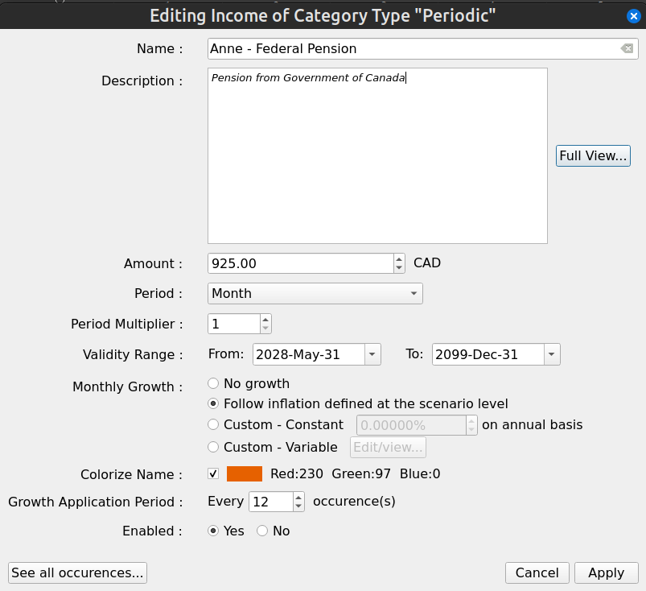

Name
Name of the Periodic Financial Stream Definition (e.g. “Salary”). 100 characters maximum. It can be an exact copy of another Financial Stream Definition’s name, but it is not a good practice.

Description
User notes for this particular Periodic Financial Stream Definition . 4000 characters maximum. Pressing the “Full View” allows for editing the content in a much bigger window.

Amount
The initial amount of money to be repeated. If there is no growth pattern defined, this amount will stay constant.

Period and Period Multiplier
The interval of repetition for the amount is specified by first defining a period type :

- Year
- Month
- End-of-month
- Week
- Day

A note on “End-of-month” : this force the events to occur at the very end of a month. Since the last day of the month changes with month (and year for leap year and February), the actual date will vary. Consider a Periodic Financial Stream defined with a period of 1 end-of-month, with validity range of [29 Feb 2000 – 5 mar 2001]. The financial events generated will be (note in particular the date “2001-02-28”) :

2000-02-29 : 1,000.00
2000-03-31 : 1,000.00
2000-04-30 : 1,000.00
2000-05-31 : 1,000.00
2000-06-30 : 1,000.00
2000-07-31 : 1,000.00
2000-08-31 : 1,000.00
2000-09-30 : 1,000.00
2000-10-31 : 1,000.00
2000-11-30 : 1,000.00
2000-12-31 : 1,000.00
2001-01-31 : 1,000.00
2001-02-28 : 1,000.00

And then a “period multiplier”, which is an integer that is a multiplication factor of the period type selected (e.g. 3 years or 12 weeks).

Validity Range
A Periodic Stream Definition is bounded by a “validity interval”, which is the period of time within which the financial events will be generated, including the “Start” and “End” points. An example of a Periodic Income would be a dividend received every 3 months or a salary received every 2 weeks. A validity interval of [1 Jan 2000 – 4 Feb 2020] means that the first amount will be generated on 1 Jan 2000 and the last one cannot go over 4 Feb 2020.

“From” date must not occur after “to” date.

Monthly Growth
The amount defined can actually change with time, by following a specified growth pattern. There are 4 options :

- “No growth” : The initial amount stays constant for the whole validity range
- “Follow inflation” : Growth is exactly identical to the inflation pattern defined in the scenario (whether “constant” or “variable)
- “Custom – constant” : Specify a constant growth, that applies only to this Periodic Stream Definition
- “Custom - Variable” : Specify a variable growth pattern, that applies only to this Periodic Stream Definition. See “Inflation” above to have more information about how to specify a variable growth. Here, inflation is exactly like growth.

Colorize Name
To make it easier to distinguish one Financial Stream Definition from another, it is possible (meaning optional) to associate a color to the name. There are 2 cases :

1) If an empty checkbox appears (default for newly created item), it means no custom color is associated to this name and system default color will be used.


2) If the checkbox is checked, with a colored square and RGB value to its right (sometimes also with a color name when it is a “standard color”), then this color is associated with the name

To associate a color to the name for case #1, select the checkbox : a color selection dialog will appear. To edit the custom color in case #2, click on the colored square : a similar color selection dialog will appear.
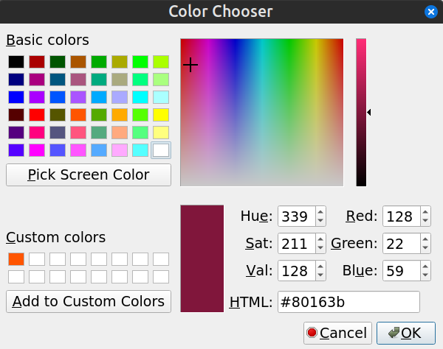
Select a color and press OK to have the color associated with the name. To apply the same color to many Financial Stream Definitions, you can copy the content of the “HTML” field and paste it as many time as required.

Growth Application Period
Determine how often the “cumulative” growth is applied to the flow of financial event occurrences. By default, it is 1, meaning that every occurrence of the amount will be adjusted with the growth pattern defined.

Sometimes however, it may be required to restrict the application of the specified growth every “n” occurrences. A good example is a rent. The amount stays constant for the duration of the rent, but needs to be augmented when the rent is renewed, by the growth accumulated over 1 year.

Lets say you have an annual rent, with 1000$ paid monthly. The renewal is on July 1st. Lets say also that you want to specify a growth of 5% annually for this amount. Then the Periodic Stream Definition to create would be something like this :

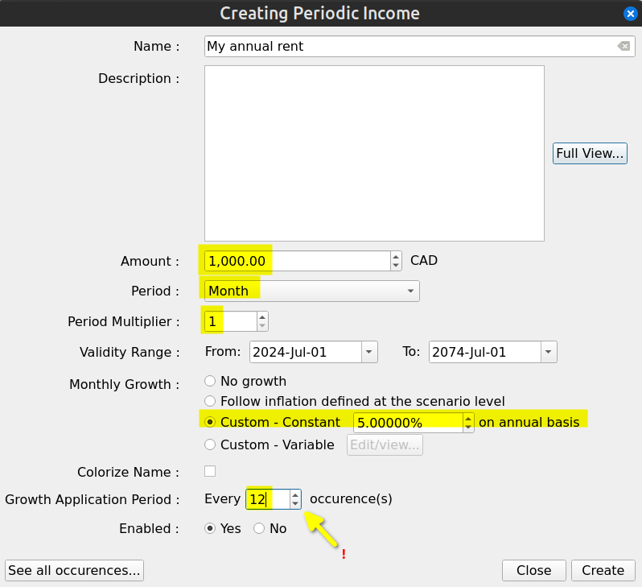
The value of Growth Application Period must be 12, in order to have 12 months of constant price rent. This would give the following financial events :

2024-07-01 : 1,000.00 CAD (cummul=1,000.00 CAD)
2024-08-01 : 1,000.00 CAD (cummul=2,000.00 CAD)
...
2025-06-01 : 1,000.00 CAD (cummul=12,000.00 CAD)
2025-07-01 : 1,050.00 CAD (cummul=13,050.00 CAD)
2025-08-01 : 1,050.00 CAD (cummul=14,100.00 CAD)
...
2026-06-01 : 1,050.00 CAD (cummul=24,600.00 CAD)
2026-07-01 : 1,102.50 CAD (cummul=25,702.50 CAD)

As expected, the monthly amount paid for the rent stays the same until 2025-07-01, when it is increased by 5%. If Growth Application Period would have stayed at the default value of 1, we would have obtained :

2024-07-01 : 1,000.00 CAD (cummul=1,000.00 CAD)
2024-08-01 : 1,004.07 CAD (cummul=2,004.07 CAD)
2024-09-01 : 1,008.16 CAD (cummul=3,012.23 CAD)
2024-10-01 : 1,012.27 CAD (cummul=4,024.50 CAD)
2024-11-01 : 1,016.40 CAD (cummul=5,040.90 CAD)
2024-12-01 : 1,020.54 CAD (cummul=6,061.44 CAD)
2025-01-01 : 1,024.70 CAD (cummul=7,086.14 CAD)
2025-02-01 : 1,028.87 CAD (cummul=8,115.01 CAD)
2025-03-01 : 1,033.06 CAD (cummul=9,148.07 CAD)
2025-04-01 : 1,037.27 CAD (cummul=10,185.34 CAD)
2025-05-01 : 1,041.50 CAD (cummul=11,226.84 CAD)
2025-06-01 : 1,045.74 CAD (cummul=12,272.58 CAD)
2025-07-01 : 1,050.00 CAD (cummul=13,322.58 CAD)
2025-08-01 : 1,054.28 CAD (cummul=14,376.86 CAD)
2025-09-01 : 1,058.57 CAD (cummul=15,435.43 CAD)
2025-10-01 : 1,062.89 CAD (cummul=16,498.32 CAD)
2025-11-01 : 1,067.22 CAD (cummul=17,565.54 CAD)
2025-12-01 : 1,071.56 CAD (cummul=18,637.10 CAD)
2026-01-01 : 1,075.93 CAD (cummul=19,713.03 CAD)
2026-02-01 : 1,080.31 CAD (cummul=20,793.34 CAD)
2026-03-01 : 1,084.71 CAD (cummul=21,878.05 CAD)
2026-04-01 : 1,089.13 CAD (cummul=22,967.18 CAD)
2026-05-01 : 1,093.57 CAD (cummul=24,060.75 CAD)
2026-06-01 : 1,098.03 CAD (cummul=25,158.78 CAD)
2026-07-01 : 1,102.50 CAD (cummul=26,261.28 CAD)

Note the same amounts for date 2025-07-01 ans 2026-07-01 !

Enabled
If “Yes” is selected (default), the Periodic Stream Definition will be taken into account in all the calculation and chart displays. If set to “No”, it wont be taken into account anywhere.

See All Occurrences
A very useful feature that takes all the values of the fields above and display all the resulting occurrences for the defined validity range.

Creating/Editing an Irregular Stream Definition
While editing a scenario:
- Pressing “New Irregular…” will display a dialog to create a new Irregular Financial Stream Definition.
- Pressing “Edit...” while a Irregular Financial Stream Definition is selected will bring essentially the same window (names of the bottom buttons change though).

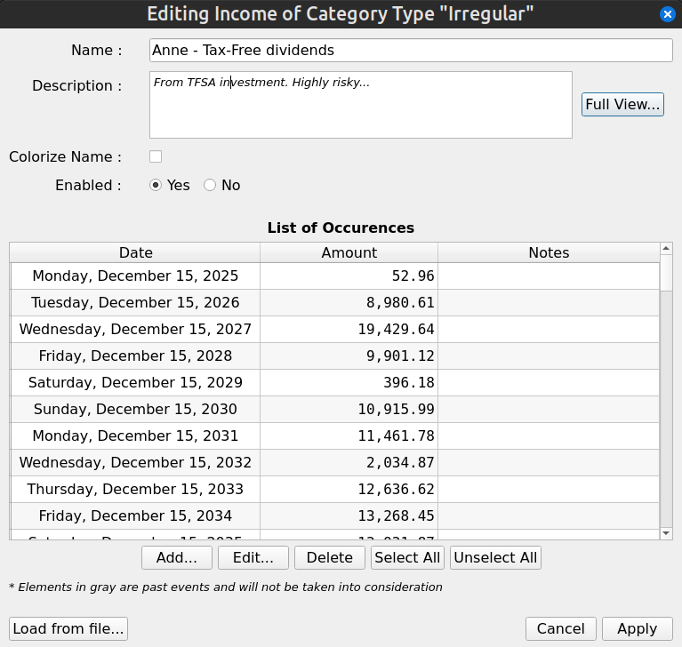

Name
Same as Periodic Financial Stream Definition

Description
Same as Periodic Financial Stream Definition

Colorize Name
Same as Periodic Financial Stream Definition

Enabled
Same as Periodic Financial Stream Definition

List of Occurrences
List of all the financial events generated by this Irregular Stream Definition.

Actions Buttons
“Add” :
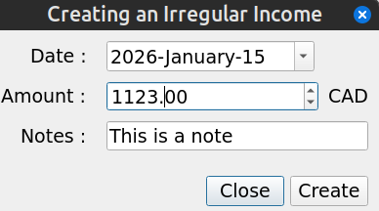
Create a new financial event (occurrence) for the Irregular Stream Definition. The date must not be already used by an existing financial event defined in this Irregular Stream Definition

“Edit” :
Same as “Add”, but if there is already another financial event that is using this date, the new amount replace the old one.

“Delete” :
The selected financial events are removed from this Irregular Stream Definition

Load From File
Import a list of financial events defined in a CSV text file. Current content is completely removed and replace by the new one. This is very useful if the financial events are computed from a complex model that is beyond the scope of this application (e.g. dividends generated by a complex portfolio of stocks) and are in great number. Entering them manually could be a tedious in that case.

The file to be imported must be a UNICODE-ENCODED text file. UTF-8 , UTF-16 and UTF-32 encodings are supported. Each line contains exactly 1 Irregular financial event. Empty lines are not allowed. Format of each line is :

<date>TAB<amount>TAB<notes>CR

where :
<date> :
date of the event. Must be in ISO 8601 format (YYYY-MM-DD). E.g. 2025-12-31
TAB :
is the TAB character (0x09)
<amount> :
a double number, without thousand separator. Decimal separator must be ".". Not smaller than 0 and not greater than :
999,999,999,999,999 for currencies with 0 decimals (e.g. Yen)
99,999,999,999,999.9 for currencies with 1 decimal
9,999,999,999,999.99 for currencies with 2 decimals
999,999,999,999.999 for currencies with 3 decimals
<notes> :
a brief description of this item. Max 100 characters. Note that this field is OPTIONAL.
CR :
carriage return character (\n )

All imported items will be tagged as "active", meaning they will be considered for the cash balance curve.

Options Window
Accessed through the “Tools→Options…” menu. Display the configuration parameters of GBP and allow modifications.

The configuration of GBP is written in an INI-style configuration file named “graphical-budget-planner.ini”. On Linux, it is located in the ~/.config directory.

When GBP starts, it tries to find this file. If found, it loads its content, otherwise it assigns default values to the configuration parameters.

When button “Save” is pressed, all changes are saved into this INI file. When “Cancel” is pressed, any changes made is discarded.

Most changes take effect immediately, unless stated otherwise by GBP with a special warning window. For example, changing the GBP font shows the following message after “Save” is pressed :

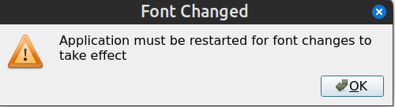

Category “General”
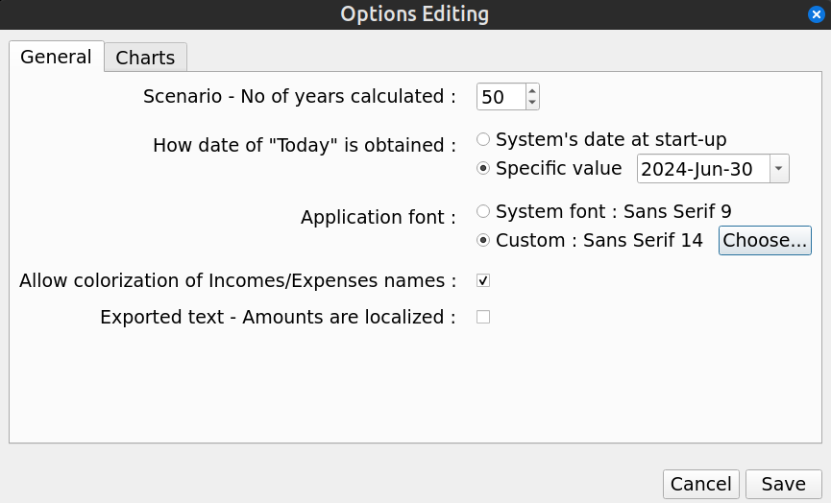

Scenario – No of years calculated
Define how long financial events will be generated for a loaded scenario. Generation starts from “tomorrow” and will terminate “x” years later, where “x” is the number specified here.

The higher the number of years is, the bigger the amount of memory used by GBP and the slower it will be to display the Cash Balance curve. It also heavily depends on the number of financial events generated during a year. It has been found however that even for slow computers (2024 standard), the calculation speed is quite good. Most “modern” computers easily handles cases with high number of financial events and “no of years calculated” up to 100.

How date of “today” is obtained
GBP is built to generate financial events from the date of “tomorrow”, which is “today” + 1 day. By default, “today” is set to the system’s date as read by GBP when it starts. This is the expected behavior, because one are interested only to future events. Every time GBP is started, user updates the field “Start Amount for Today”, which provide the current amount of cash available as of “today”. The section “Usage” describes how GBP is expected to be used and provide more details.

There are some use cases however where it is beneficial to always have “today” set to a specific and constant value. One such case is testing, where repeatability of initial conditions is required. Another case is when user decides to “freeze” the view in time at a specific moment, because it fits better his own way to update scenario data.

For those cases, it is possible to “freeze” the value of “today” to a specific date. Every time GBP will starts, it will use this value and discard the true current date obtained from the system. The value of “Today” is displayed at the bottom of the Main Window.

Application Font
By default, GBP uses the default system font to display text strings. If user prefers a different font style and/or font size, it may set this font by selecting first the “Custom” radio button and then press the “Set” button. He will then be able to select the required font. Application must be restarted for the change to take effect.

To return to default font, just select the “System Font” radio button.

If ever the user selects a font that make the text unreadable, GBP can be started in a terminal window with the argument “-usesystemfont”. This will reset the font to system font.

Allow colorization of Incomes/expense names
Enable or disable the colorization of names for all Financial Stream Definitions. This can be useful if a scenario is used on an OS where custom theming makes difficult the reading of colorized name. “Disable” means that default Operating System text color will be used.

Exported text – Amount are localized
When checked, in exported CSV file, amounts will be written using convention of the system Locale. For example, on a French system, the amount 12345.67 would be written : 12 345,67

Category “Charts”
These settings are specific to curves and charts.
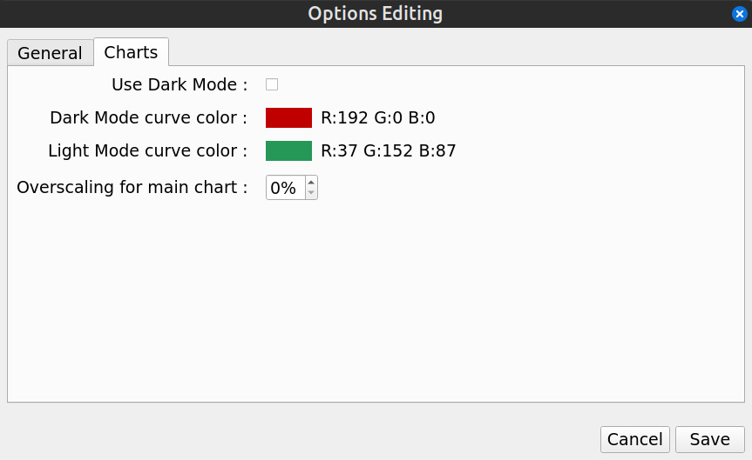

Use Dark Mode
GBP cannot detect which theming mode the host operating system is using. So to help adapt, the Options Dialog offers a way to change how the charts look. When checked, Dark Mode is used for all the charts (black background with bright foreground text).

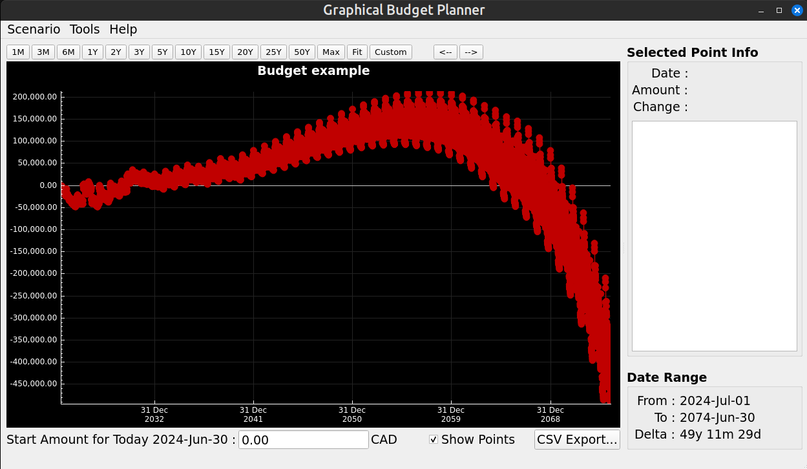
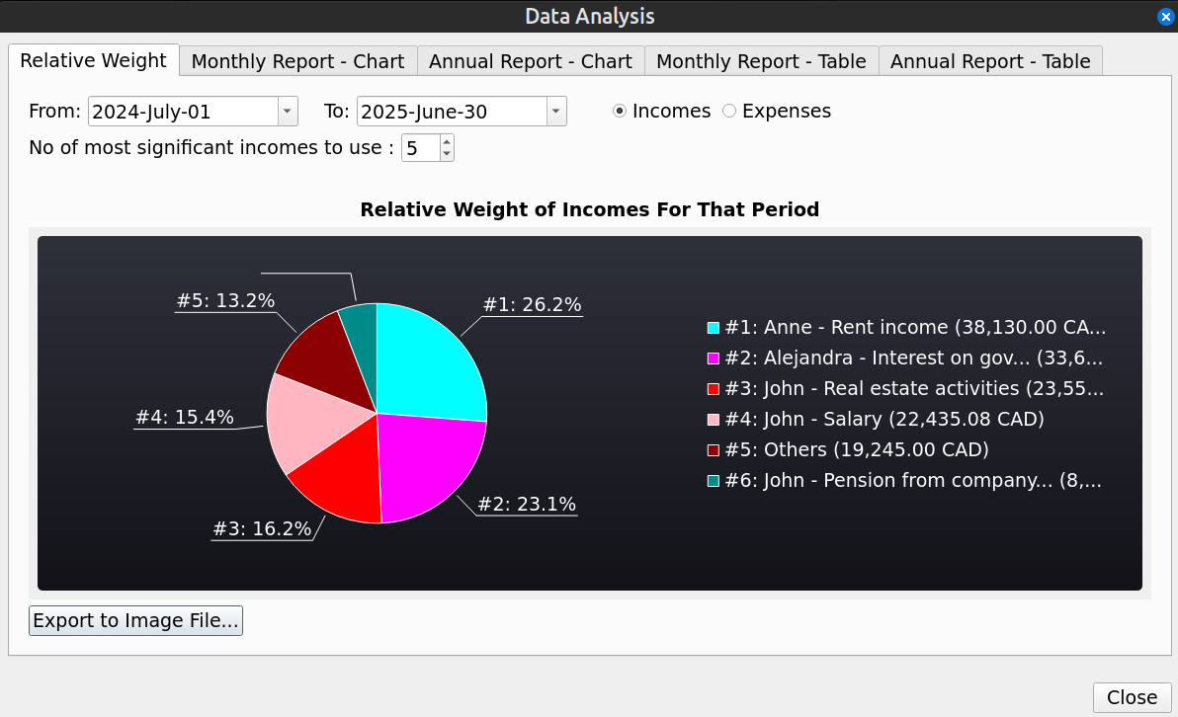
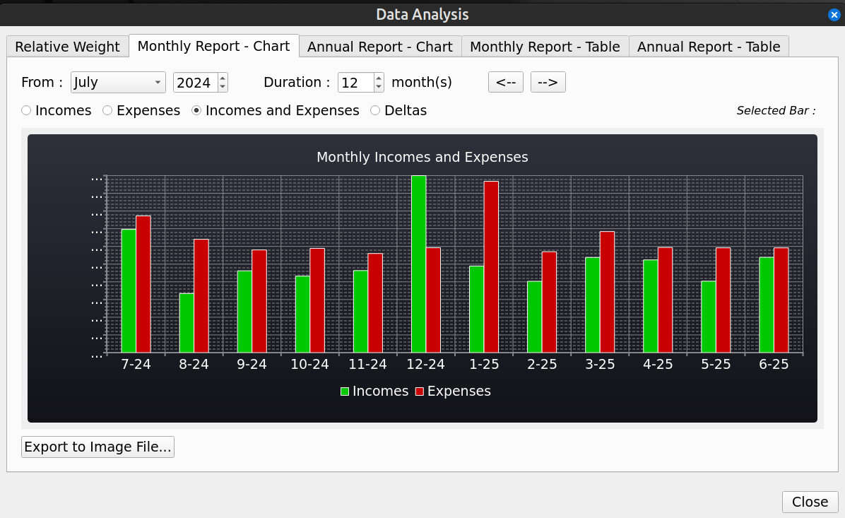
When unchecked, Light Mode theming is used. That means white background on dark colored text.

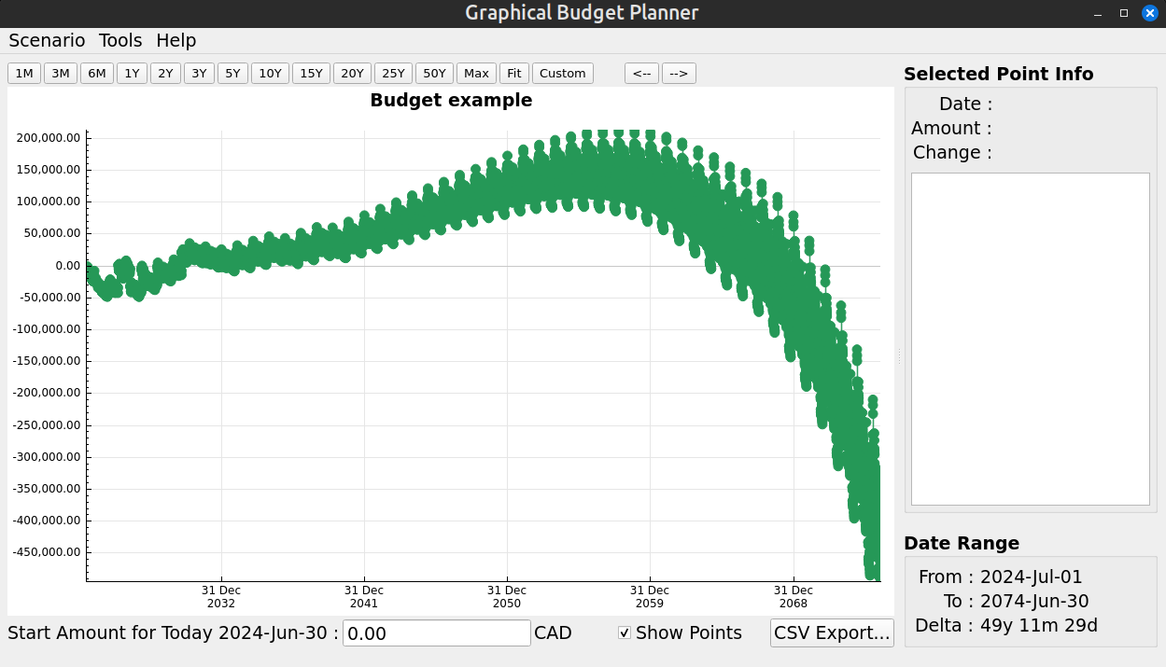

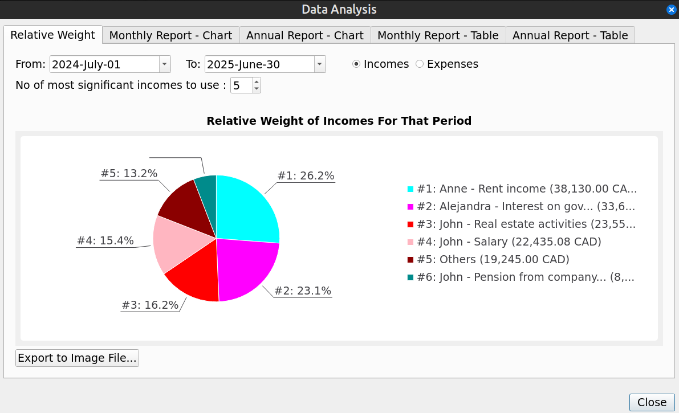
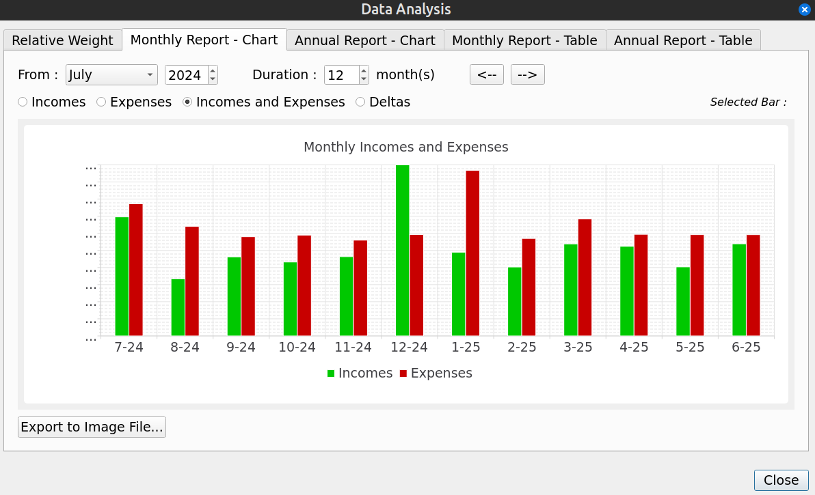

Dark Mode Curve Color
This set the color of the Cash Balance curve of the Main Window when Dark Mode option has been checked. To set the color, press on the colored square.

Light Mode Curve Color
This set the color of the Cash Balance curve of the Main Window when Dark Mode option has been unchecked. To set the color, press on the colored square.

Overscaling for main chart
This applies only for the Cash Balance curve displayed in the Main Window. It sets the level of “overscaling” to be applied on the charts X and Y axis. 0% means no overscaling,

By default, there is no overscaling applied. That means that the X and Y axis minimum and maximum match exactly the min/max values of the data points shown. This may lead to a problem clicking on such points, because the representation disk is clipped :

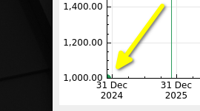
To alleviate this problem, GBP can “overscale” the X and Y axis, so that the min/max points are fully contained in the chart. For example, a 2% overscaling would produce the following result with the previous data shown :
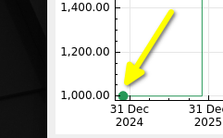
A 5% overscaling would gives :
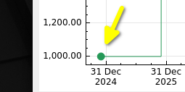
The inconvenient of overscaling is that, when one specifies a range with the upper toolbar buttons, the displayed chart is actually wider. For example, using the “Custom” range button to set an interval of [1 jan 2025 – 31 dec 2025], we get the following result for a 5% overscaling :

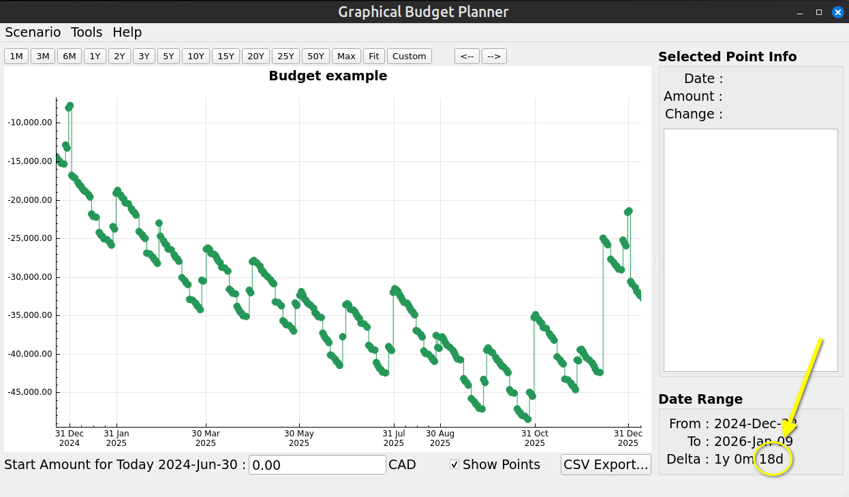
Note the “18 more days” over the 1 year requested. 18 days is 5% of 1 year.

Analysis Window
This window provides more in depth analysis of the resulting financial events stream displayed by the Cash Balance curve in the Main Window.

Relative Weight Tab
A very important analysis module that provides quite useful information on the current scenario budget. Its goal is to show on a pie chart the comparative weight of either incomes or expenses, spread over a user-specified time interval.

For example, it will tell you what are the biggest expenses expected during the next 2 years or what is the percentage of the 10 most important incomes compared to all the expected incomes for the next 10 years.

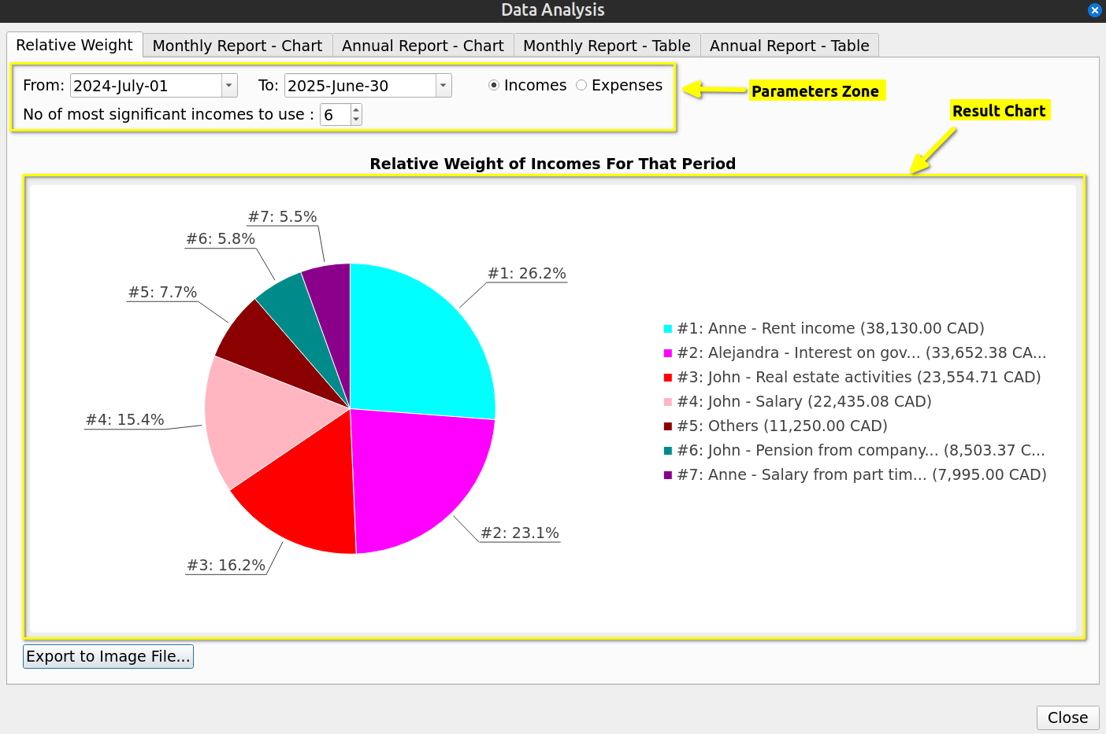

Parameters Zone
This is where you can change parameters that affect the calculation of the Pie Chart below

From
Specify the start of the time interval to consider in the calculation. Financial Events occurring before this date will not be taken into account.

To
Specify the end of the time interval to consider in the calculation. Financial Events occurring after this date will not be taken into account. Must not be smaller than ”To” date.

Incomes / Expenses Radio buttons
Specify if we want to consider incomes or expenses (cannot do both at the same time)

No of most significant incomes/expenses
Specify how many slices the pie chart will have. If this number is greater than the total number of incomes (or expenses), then it is the latter that is used. In some cases, there may actually be 1 more slice, dedicated to all the “other” incomes (or expenses) taken all together (named “Others” on the chart). The “Others” slice wont be present if the total no of incomes (or expenses) <= the value of this field (because there is none left...)

Result Chart
The area where the chart is displayed, along with the legend mapping the pie color to the actual incomes (or expenses). Colors of the slices are pre-configured and cannot be changed by the user.

Exporting to Image File
Pressing this button allows the chart to be saved in an image file. A dialog will be shown required a file name and a destination directory. The image file created will always be a PNG file with lossless compression.

Monthly Report - Chart
This chart is a monthly report, displayed as a Bar Chart.
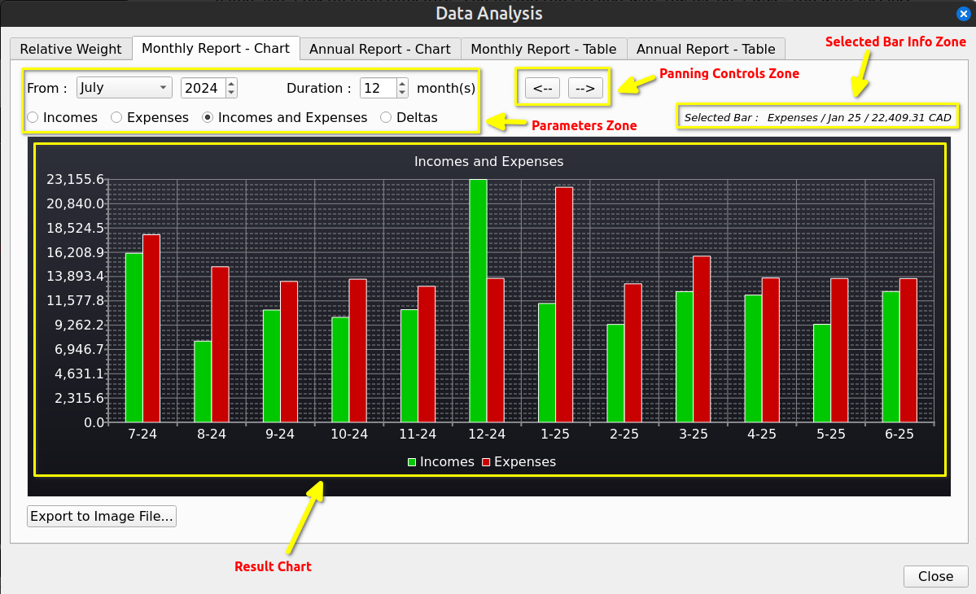

Parameters Zone
This is where you can change parameters that affect the calculation of the Bar Chart below

From
Specify the start of the time interval to consider in the calculation, that is the first month considered. Financial Events occurring before this date will not be taken into account.

Duration
Set how many months to display in the bar chart, including the month specified by “From”.

Incomes / Expenses / Deltas
Specify what information will be displayed in the Bar Chart.
  - Incomes : Only Financial Events that are incomes will be used in the calculation of the Bar Chart
  - Expense : Only Financial Events that are expenses will be used in the calculation of the Bar Chart
  - Incomes and Expenses : All Financial Events (incomes and expenses) will be used in the calculation of the Bar Chart
  - Deltas : All Financial Events are used, but the Bar Chart will display the results of Incomes – Expenses.

The Deltas option is particularly useful to watch the evolution of “monthly surplus” over the years : bars in green show surplus, bars in red show deficit

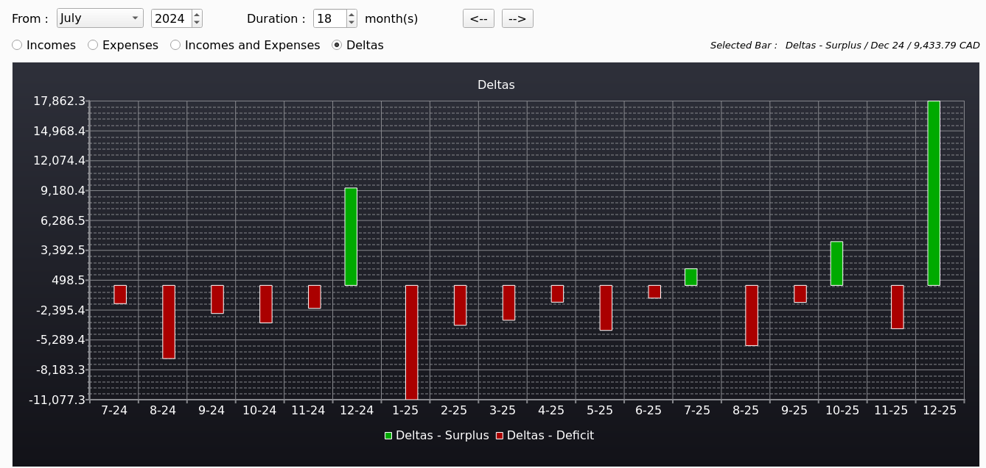

Result Chart
This is where the Bar Chart is displayed. User can click on a specific bar to see more related information in the “Selected Bar Info Zone”.

The “Export to Image File” button allows for exporting the displayed Bar Chart as an image file. See section Relative Weight Tab.

Panning Controls Zone
The 2 buttons shift the Bar Chart to the left or right, by an amount of months equal to the “Duration”. It is as a matter of facts a way to scroll the Bar Chart.

Annual Report – Chart
Exactly like the “Monthly Report – Chart”, except that the data is aggregated by year instead month.

Monthly Report – Table
For all the Financial Events generated for the scenario, produce a table holding, for each month, the following information :
- the month
- Total incomes for the month
- Total expenses for the month
- Total incomes – total expenses for the month

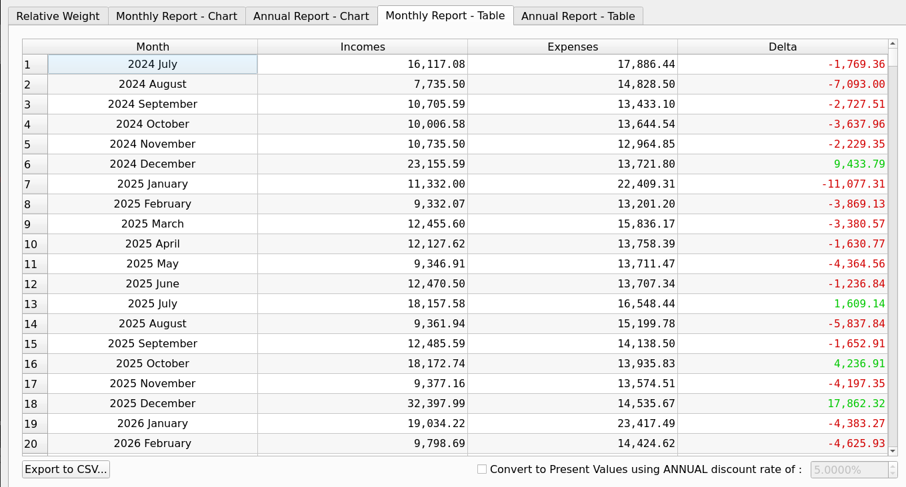

Convert to Present Values
If this checkbox is checked, all the amounts of the table (which are in the “future”) are converted to the Present Value using the annual discount rate chosen by the user. This is helpful, because otherwise an amount of X in the future is misleading, since it has not the same value as today. For example, a surplus of 54,078 in 50 years represents actually just 4,754 in today’s present value with a discount rate of 5%.

Export To CSV
See CSV Export

Annual Report - Table
Exactly like the “Monthly Report – Table”, except that the data is aggregated by year instead month.

Usage

Preparing to create a budget

Collecting Information
A budget in GBP is called a “scenario”. The name comes from the fact that you can create as many budgets as you want with the application, each one being a specific “scenario” covering a given set of options or possibilities.

Before creating a new budget, you must remember that GBP will focus only on the future incomes and expenses to come. The past is irrelevant for GBP and essentially discarded.

First, make a list of all sources of incomes and expenses you think will happen from tomorrow to several years in the future. For each of them, determine :
- if it is a recurring amount, that is, it repeats itself at identical time intervals of either days, weeks, months, end-of-month or years : if so, it is probably of type “Periodic”. Otherwise, the type is “Irregular”
- for Periodic incomes/expenses, what is the first day it occurs and when will it ends ?
- for Periodic incomes/expenses, is the amount constant through time or is it changing ? In the latter case, if the change if not governed by one of the 2 rules below, then it is most probably better to use an “Irregular” type
  - constant growth : a simple constant growth percentage, per year or per month
  - variable growth : a complex growth pattern that identifies exactly all the growth transitions that occur in time, using a list of (date, growth value in percentage)

Then try to determine the level of inflation you want applied to the scenario. As a reminder, inflation, once defined, is offered as one possible option to define growth for a Periodic Stream Definition. It is NOT applied automatically to all incomes/expenses. A simple case to define the value of inflation is to set it constant through the years (can be 0% or even negative if you want). For a more complex situation (this is more advanced stuff), you can model inflation that varies through the months and years. See the example below

Modeling Inflation that Varies Through the Months and Years
Lets say that we want to model inflation more precisely than the “constant” value option offered. Lets say we want this :
- From 1 Feb 2025 : 5% on an annual basis
- From 1 nov 2025 : 4% on an annual basis
- From 1 Jan 2027 : 2% on an annual basis

For that, we need to define a “variable inflation” pattern for the scenario.

The list of transition dates and values will be entered as follows :

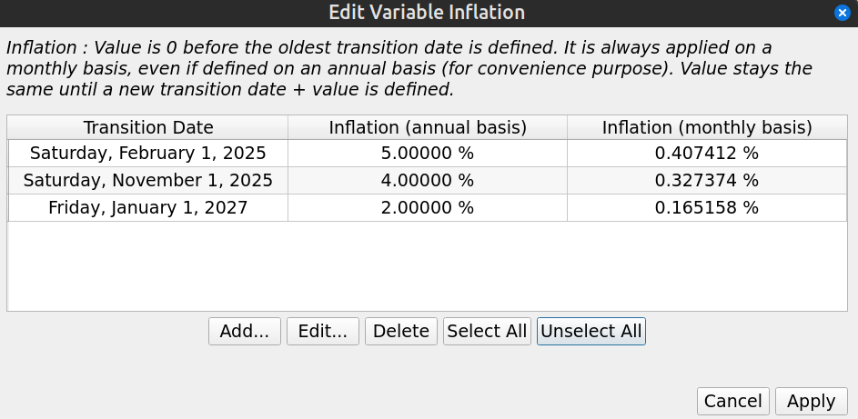
With that definition, the inflation used in the scenario would be as follow :
- From past to Jan 1 2025 : 0% applied on the 1st of every month
- From Feb 1 2025 to Oct 1 2025 : 0.407412% applied on the 1st of every month
- From Nov 1 2025 to Dec 1 2026 : 0.327374% applied on the 1st of every month
- From Jan 1 2027 to infinity : 0.165158% applied on the 1st of every month

Practical Examples of Periodic Incomes/Expenses

Salary Received Every 2 Weeks, No Growth
Period is “week”, Period Multiplier is 2. Start Date in the Validity Range must be the first day of occurrence (here on Friday).

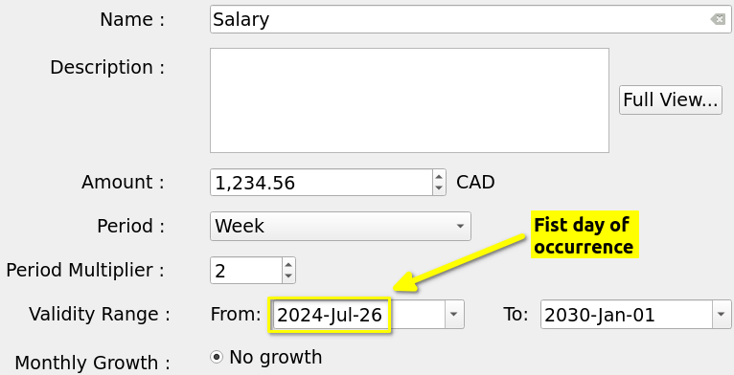
The salary will repeat until it reaches the upper end of the Validity Range

2024-07-26 : 1,234.56 CAD (cummul=1,234.56 CAD)
2024-08-09 : 1,234.56 CAD (cummul=2,469.12 CAD)
2024-08-23 : 1,234.56 CAD (cummul=3,703.68 CAD)
.
.
.
2029-12-07 : 1,234.56 CAD (cummul=174,072.96 CAD)
2029-12-21 : 1,234.56 CAD (cummul=175,307.52 CAD)

Salary Received Twice a Month (15th , End of Month), No Growth
This one is a little bit tricky, because we we look at it closely, it is NOT a regular time interval (end of month can be 28,29,30,31). To fix that, we need to have 2 separate incomes : Salary 1 and Salary 2. The first one is on the 15th with a period of 1 Month. The second must starts at a real end-of-month (Start Date of Validity Range), like 31 July, and have a Period of “1 end-of-month”. This is set in GBP like this :

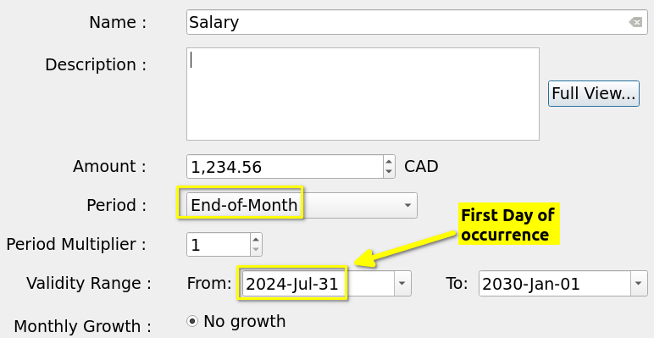
Salary 2 will generate the expected Financial Events : note how the end-of-month date changes

2024-07-31 : 1,234.56 CAD (cummul=1,234.56 CAD)
2024-08-31 : 1,234.56 CAD (cummul=2,469.12 CAD)
2024-09-30 : 1,234.56 CAD (cummul=3,703.68 CAD)
2024-10-31 : 1,234.56 CAD (cummul=4,938.24 CAD)
.
.
.
2029-10-31 : 1,234.56 CAD (cummul=79,011.84 CAD)
2029-11-30 : 1,234.56 CAD (cummul=80,246.40 CAD)
2029-12-31 : 1,234.56 CAD (cummul=81,480.96 CAD)

An Annual Rent with Fixed Monthly Payment
Lets say we have a rent with a 1000$ monthly payment, renewed every 12 month with a rent increase of 5 %. Monthly payment are constant within a 12 month contract. This can be modeled in GBP the following way :

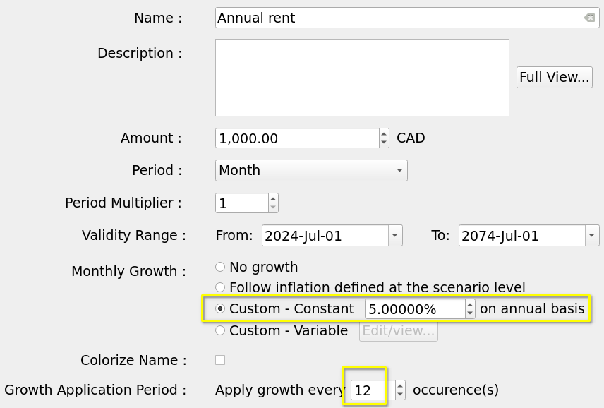
The Period is “1 monthly”, since we pay the rent every month. The amount is 1000. Growth is set to “Constant – 5% annually). The trick here is to set “Growth Application Period” to 12, because we want the rent raise to be applied only once a year, at renewal. The generated Financial Events will be, as expected :

2024-07-01 : 1,000.00 CAD (cummul=1,000.00 CAD)
2024-08-01 : 1,000.00 CAD (cummul=2,000.00 CAD)
2024-09-01 : 1,000.00 CAD (cummul=3,000.00 CAD)
...
2025-06-01 : 1,000.00 CAD (cummul=12,000.00 CAD)
2025-07-01 : 1,050.00 CAD (cummul=13,050.00 CAD)
2025-08-01 : 1,050.00 CAD (cummul=14,100.00 CAD)

Weekly Grocery Bill that Follows Scenario’s Inflation
This is a weekly expense that should follow inflation, which we set at 5% in the scenario. So Period is “1 week” and growth must be set to “Follow inflation”. Lets assume a 300$ weekly grocery expense. Lets also add some notes in the description. In GBP, we then have this Periodic Financial Stream Definition :

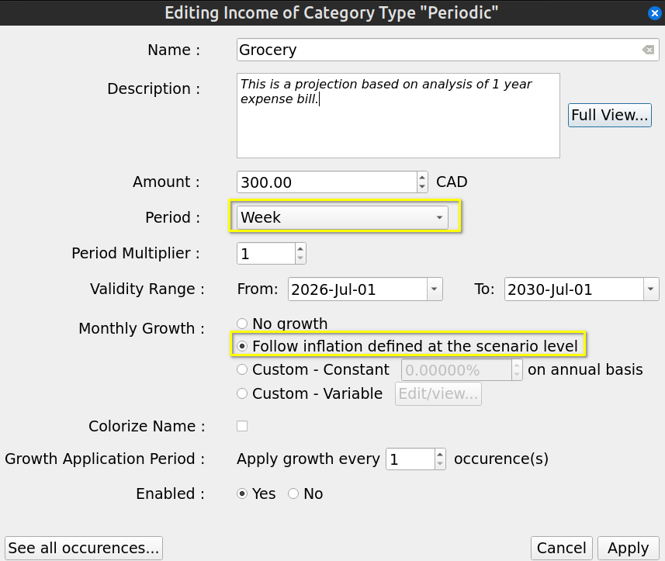
Since inflation (and any defined growth for any Financial Stream Definition) is always converted internally to monthly value and applied on the 1st of each month, we should have the weekly grocery expense stay the same for a whole month. Monthly growth will be 0.4074% (equivalent of 5% annual). Also, remember that the first occurrence never has growth applied. We then get, as expected :

2026-07-01 : 300.00 CAD (cummul=300.00 CAD) <= no growth applied for first occurence
2026-07-08 : 300.00 CAD (cummul=600.00 CAD)
2026-07-15 : 300.00 CAD (cummul=900.00 CAD)
2026-07-22 : 300.00 CAD (cummul=1,200.00 CAD)
2026-07-29 : 300.00 CAD (cummul=1,500.00 CAD)
2026-08-05 : 301.22 CAD (cummul=1,801.22 CAD) <= Monthly inflation applied
2026-08-12 : 301.22 CAD (cummul=2,102.44 CAD)
2026-08-19 : 301.22 CAD (cummul=2,403.66 CAD)
2026-08-26 : 301.22 CAD (cummul=2,704.88 CAD)
2026-09-02 : 302.45 CAD (cummul=3,007.33 CAD)

Monthly Loan Payment at Each End-Of-Month
Lets say we have a loan payment of 100$ that is due at every end of month, with the first occurrence being on 30 nov. In GBP, that translates to :

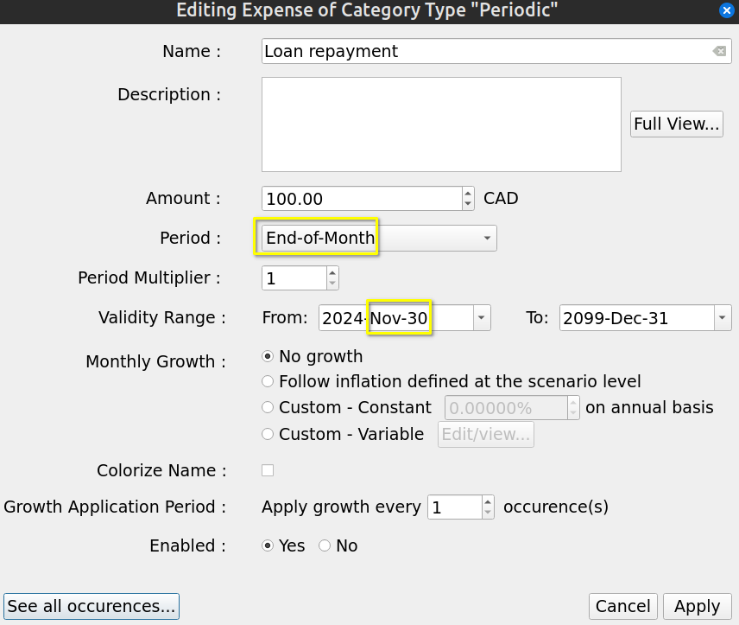
The use of “End-of-Month” for the Period make sure that, as we go forward in time, one always get the real end of month, and not just “date + 1 month” as it would be if we would use Period = “Month”. The resulting Financial events are, as expected :

2024-11-30 : 100.00 CAD (cummul=100.00 CAD)
2024-12-31 : 100.00 CAD (cummul=200.00 CAD)
2025-01-31 : 100.00 CAD (cummul=300.00 CAD)
2025-02-28 : 100.00 CAD (cummul=400.00 CAD)
2025-03-31 : 100.00 CAD (cummul=500.00 CAD)
2025-04-30 : 100.00 CAD (cummul=600.00 CAD)
2025-05-31 : 100.00 CAD (cummul=700.00 CAD)

Monthly Car Maintenance That Increases By a Variable Amount
Lets say we have a 50$ monthly car maintenance fee. We want this amount to increase by a different growth rate each year, because the car is getting older. Let say that :
- Year 1 : 5% increase (annual basis)
- Year 2 : 10% increase (annual basis)
- Year 3 : 15% increase (annual basis)
- Year 4 and following : 20% increase (annual basis)

To model that in GBP, we have to use a variable growth rate applied to a Period Stream Definition. Like this :

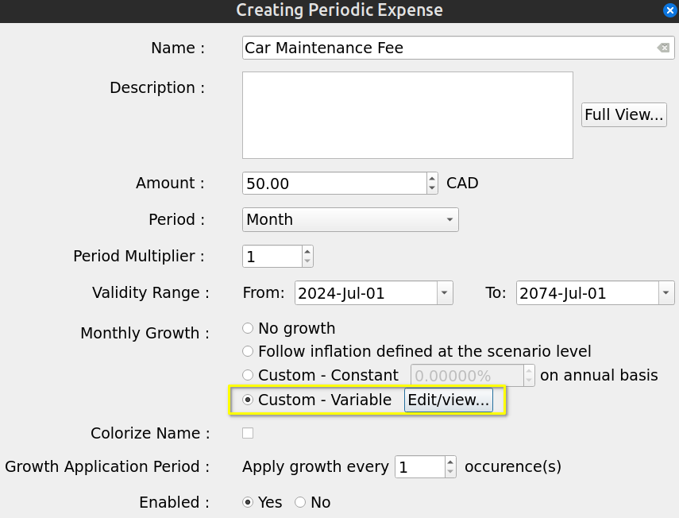
with the definition of the variable growth like the following :

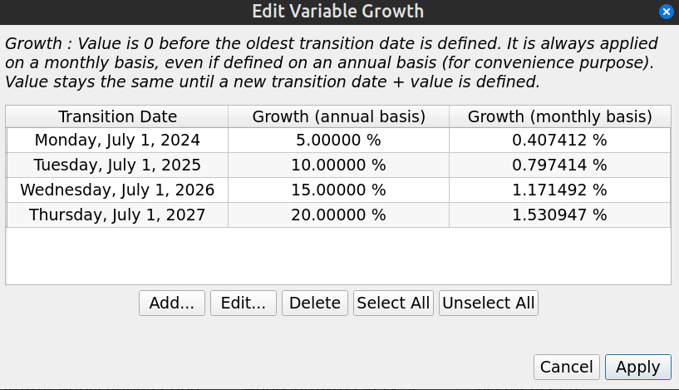
We get the following Financial events, which are as expected :

2024-07-01 : 50.00 CAD (cummul=50.00 CAD) <= growth never applied on the first occurence
2024-08-01 : 50.20 CAD (cummul=100.20 CAD) <= growth of 0.4074%
2024-09-01 : 50.41 CAD (cummul=150.61 CAD) <= growth of 0.4074%
...
2025-06-01 : 52.29 CAD (cummul=613.61 CAD) <= growth of 0.4074%
2025-07-01 : 52.70 CAD (cummul=666.31 CAD) <= new growth of 0.7974%
2025-08-01 : 53.12 CAD (cummul=719.43 CAD) <= growth of 0.7974%
...
2026-06-01 : 57.52 CAD (cummul=1,274.55 CAD) <= growth of 0.7974%
2026-07-01 : 58.19 CAD (cummul=1,332.74 CAD) <= new growth of 1.1715%
...
2027-06-01 : 66.14 CAD (cummul=2,019.61 CAD) <= growth of 1.1715%
2027-07-01 : 67.16 CAD (cummul=2,086.77 CAD) <= new growth of 1.5309%
...
2028-06-01 : 79.37 CAD (cummul=2,896.93 CAD) <= growth of 1.5309%
2028-07-01 : 80.59 CAD (cummul=2,977.52 CAD) <= STILL growth of 1.5309%

Practical Examples of Irregular Incomes/Expenses

One-time Tax Return
A one-time event is easily modeled in GBP with an Irregular Stream Definition. If for example one plans to receives a 1000$ tax return on May 15 2025, this would look like this :

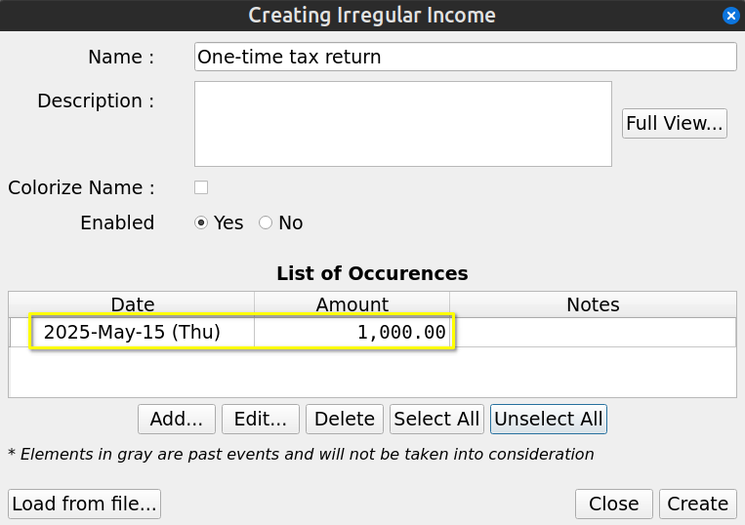
The list of occurrences hold the expected Financial Events. Use “Add” button to create a new one, “Edit” to modify an existing one, “Delete” to remove all items selected.

Irregular Incomes from Selling Goods
When a set of incomes occurred at irregular intervals, the best approach is to use Irregular Stream Definition. For example, if you expect the following incomes from selling some furnitures before moving to a new place :
- 25 nov 2026 : 2000$
- 30 jan 2027 : 1500$
- 4 jun 2027 : 1200$

This would translates in GBP with the following Irregular Stream Definition :

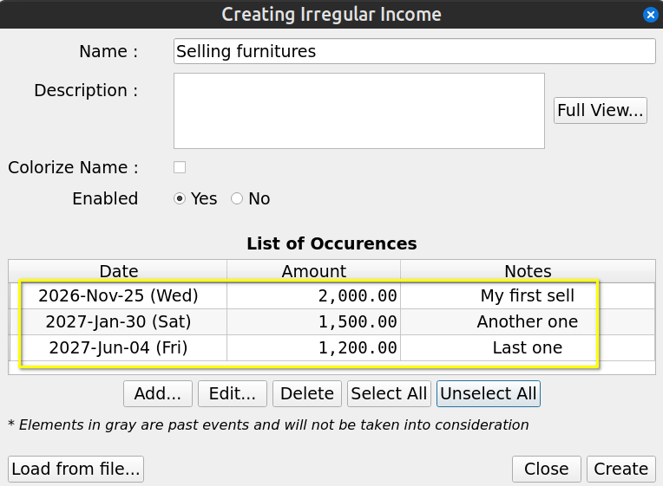

Periodic Expenses but Irregular Amounts
Even if a set of Financial Events occur at regular periodic intervals, it does not means this should be modeled as Periodic Financial Stream. In the case where amounts are not constant or cannot be simply determined by Growth pattern (constant or variable), then Irregular Stream Definition is the way to go.

Lets say we get dividends from a investment portfolio every 3 months. The amount varies enormously and are given by :
- 31 jan 2026 : 5000$
- 30 avr 2026 : 10000$
- 31 july 2026 : 25000$

In GBP, we would have the following Irregular Stream Definition :

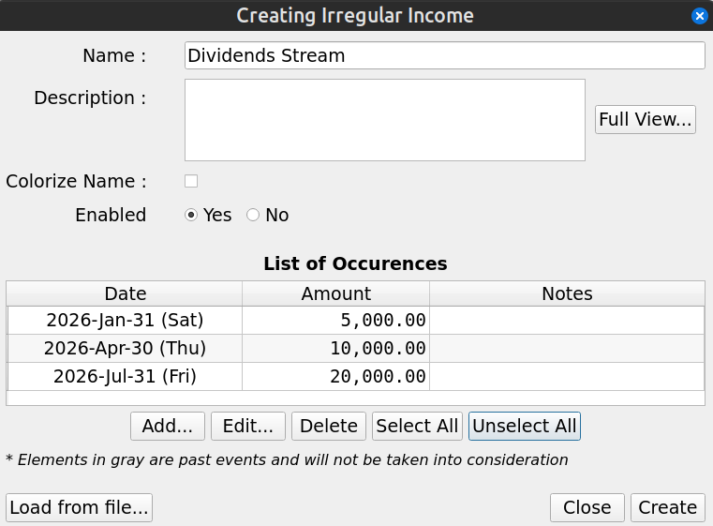

Importing a Complex Set of Incomes
In the case where a set of incomes are determined by a complex model external to GBP, it is possible to import the result in a GBP Irregular Stream Definition with the help of a CSV file.

To do so, create a new Irregular Stream Definition and press the “Load from file” button at the bottom left :

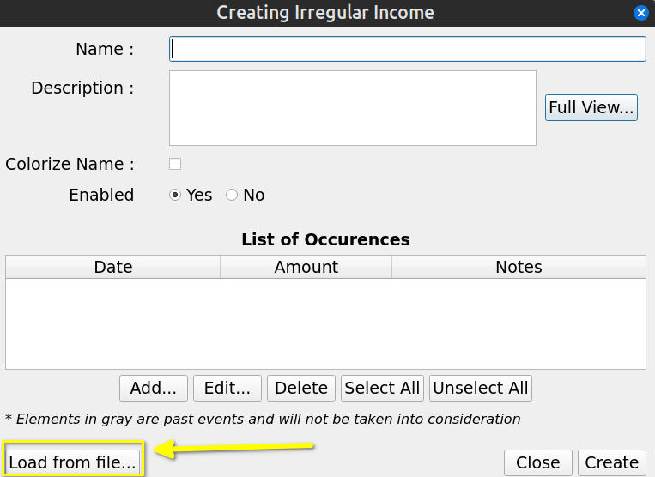
The File import Dialog is shown : proceed by selecting a CSV file using the “Browse” button and press “Import” :

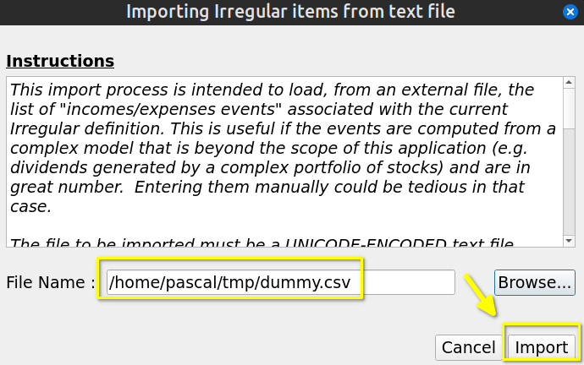

The content of the CSV file will be brought into the irregular income, replacing the current content :

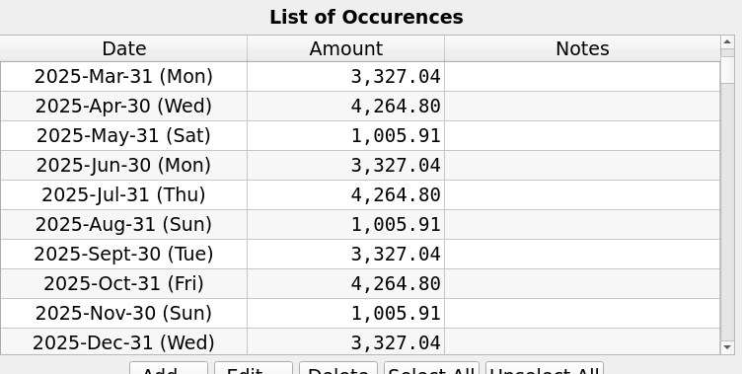

Creating the Budget in GBP
Once you gather all this information, you can create a new scenario by using the “Scenario→New…” menu. The following Dialog will be shown :

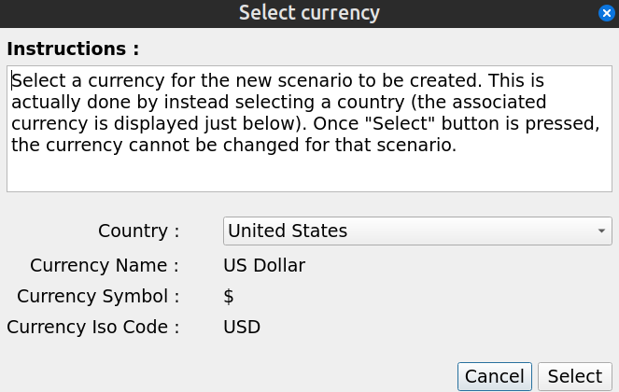
Select the currency to be used in the scenario by selection a country. After pressing “Select”, you will have access to the “Edit Scenario” Dialog : enter the collected data and then press “Create Scenario” button at the bottom right.

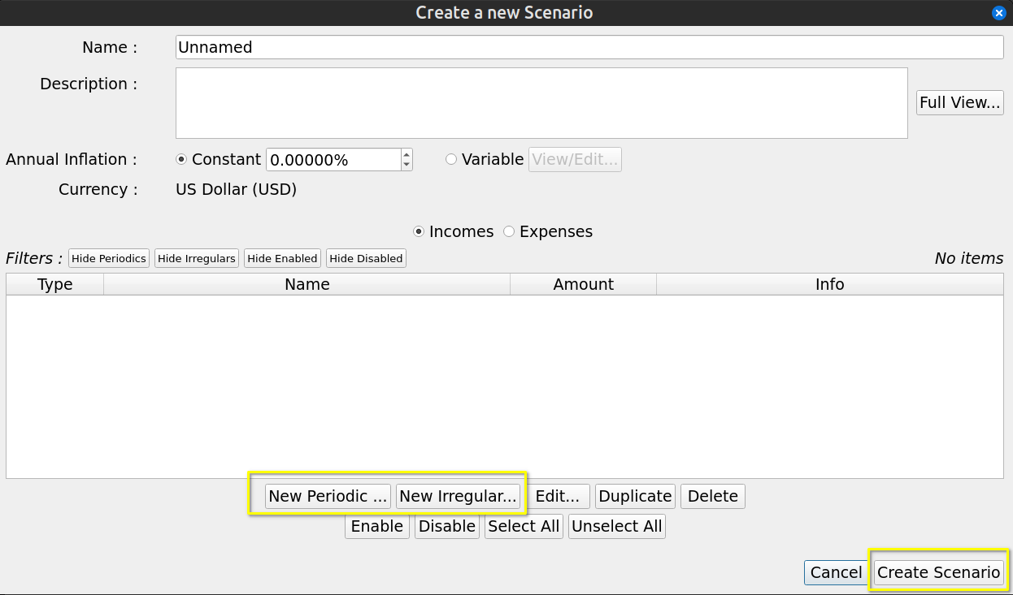
The last step would be to save the scenario in a disk file, using the “Scenario→Save As…” menu.

Using a Budget Scenario Over Time

Typical Workflow
Once a budget is created, user will launch the program from time to time in order to either look at the budget, to modify the scenario’s data or to make some analysis. The following is a brief description of the typical way to use GBP, as intended by the author.

The standard workflow relies on the default behavior of GBP to read the date of “today” from the system’s date at launch time. This can be changed in the Options Window, but in that case it leads to the “alternate workflow” described in the following section.

Set “Start Amount for Today” Value
First, right after launching GBP and a scenario is loaded, the user should update as soon as possible the “Start Amount for today” value. The basic assumption behind this approach is that it is easy to collect the net cash balance of the user (e.g. by looking at the balance of all “checking” bank accounts) or net value. This is what is entered in the “Start Amount for Today” field, as it represent the current cash balance as of “today” (or net value) and constitutes the initial condition on top of which the future incomes/expenses will be added. Think of it as a “baseline”.

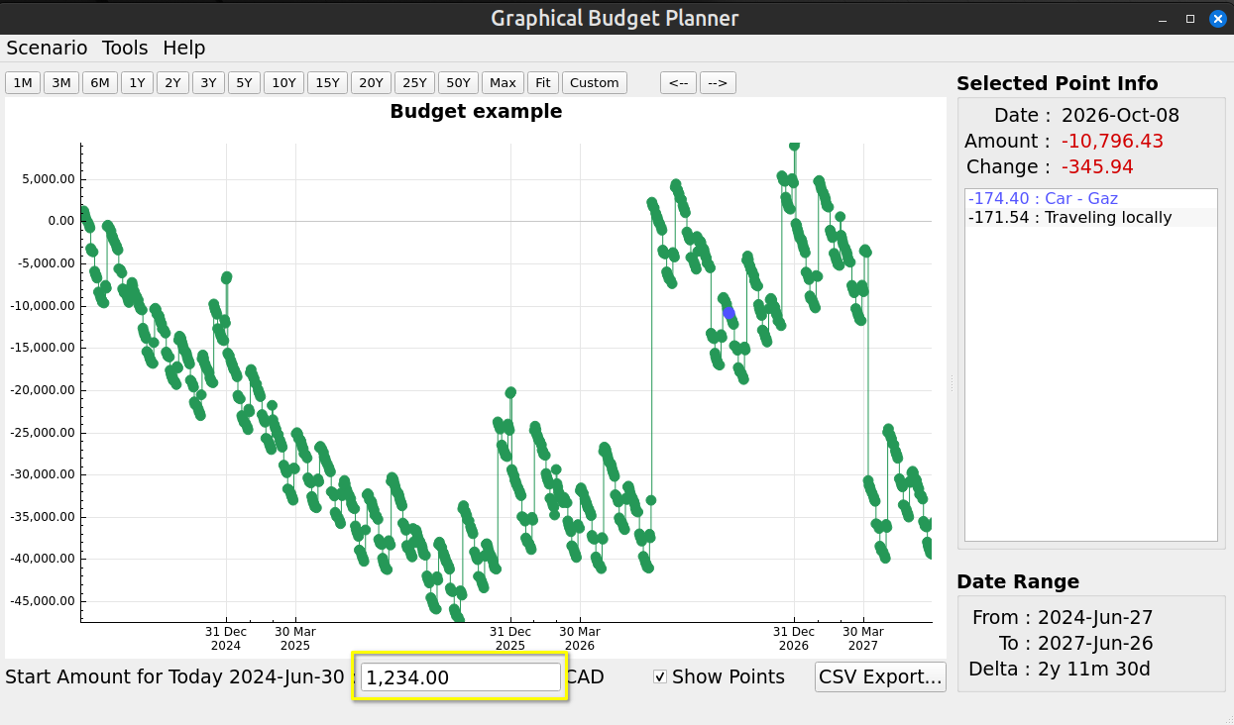

Inspect the Cash Balance Curve and Analysis Module
Once this is done, user will typically do the following :
- Spend a lot of time changing the range of the displayed Cash Balance curve (zooming, panning, predefined range buttons at the top) and looking at how the cash balance evolves over time. This gives a good idea of how well the user is doing.
- Selecting miscellaneous points in order to know what Financial Events occurred in a specific day and see their effects.
- Looking at the Analysis module to inspect the evolution of monthly/yearly cash balance or to evaluate the relative weight of incomes/expenses over a custom period of time. The latter allows for quick identification of the most impactful incomes or expenses.

These activities will allow the user to better understand his current financial situation and help making appropriate decisions, which is the goal of GBP. For example :
- If the cash Balance curve gets dangerously close to 0 during a certain period of time, user may decide to delay or to reduce some expenses, like vacations, buying a new car, etc, or rather increase its incomes.
- A monthly cash balance (as reported in Analysis module) that is decreasing over time may lead to the conclusion that some decisions are required in order to be in better shape financially speaking

Play with the Scenario Data and Look at the Results
- By changing the amounts of some Financial Stream Definitions and see the effect on the curve, user can see if he can afford certain expenses (e.g. “Should I reduce the budget allocated to eating out and by how much ?”)
- Many simulations can be conducted by playing with the Financial Stream Definitions of a scenario, including enabling/disabling them, in order to see the financial impact of major life changing decisions (e.g. retirement, changing job, starting a business, moving to a different country, doing a PHD or not, go back to school, downsizing the housing expectation)

Improve Readability Using Colorization of Name
In order to distinguish groups of incomes/expenses from one another, user will typically use the “Colorize Name” feature of a Financial Stream Definition. For example, he may use blue color to identify expenses related to car :

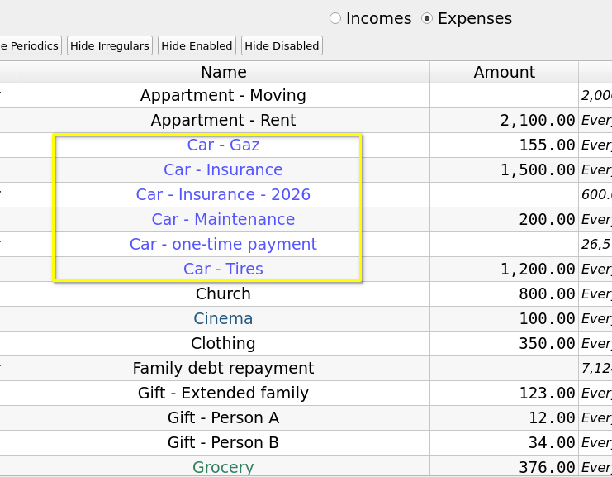
Not only is it easier to identify them in the list of Financial Stream Definitions in the “Edit Scenario” window, but identification is also easier in the “Selected Point Info” of the Main Window :

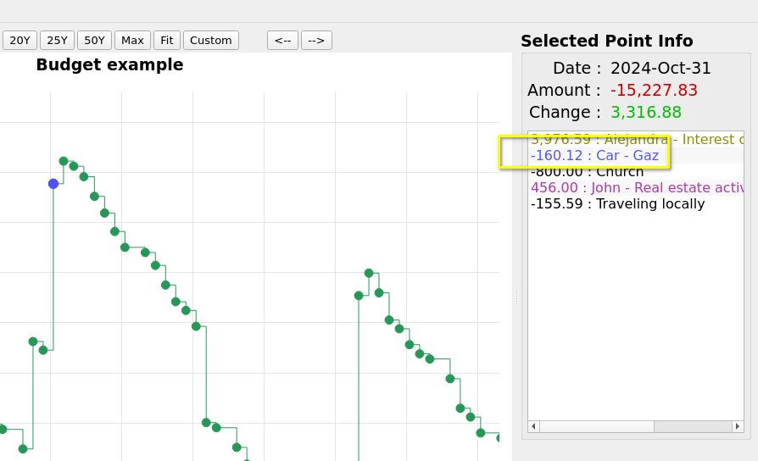

Alternate Workflow

What Is the Alternate Workflow ?
It is essentially the same as the “typical” one, with one very important difference : the date of “today” is not read from system’s date at startup (which is the default behavior), but is rather set to a custom value obtained from GBP configuration settings.

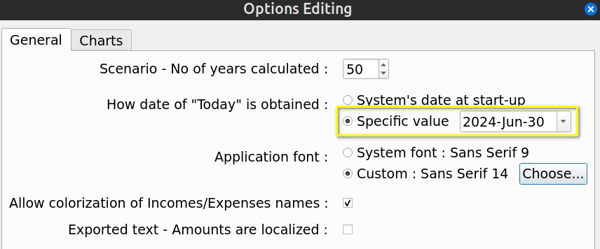
This means that the view provided by GBP is “frozen in time”, since the date of “today” does not change each time the program is launched. The date of “today” can be seen at the bottom of the Main Window :

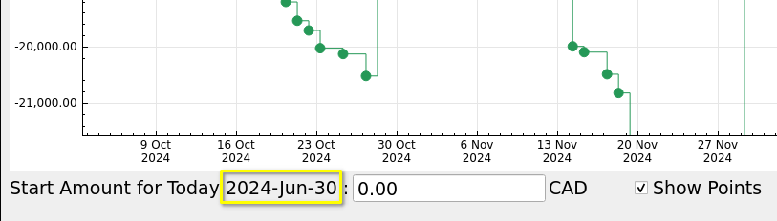

When Can this Alternate Workflow Be Useful ?
There could be some situations where :
- For an income/expense, you may have configured it to occur at a specific day in the month for example, but in reality you don’t know for sure when it occurs
- For an income/expenses, the day of occurrence may change from time to time.
- The current cash balance can be difficult to collect

For example :
- Case 1 - Periodic monthly Health Care expense : you may set it for the 15 of every month, for convenience purpose, but in reality it may happen anytime in the month, more than one time. You could also decide to make it a daily expense, which kind of average it out and makes the use of the alternate workflow not required. But the inconvenient is that you will get a lot of Financial Events daily that are “less real”.
- Case 2 - Periodic investment incomes due for end-of-month : you may get them sometimes earlier in the month. It could be dividend payments that you scheduled every end-of-month for sake of simplicity, but in reality they occur at different moments in a month from time to time. For example :
    - mars 2035
      - on the 15th : monthly dividend from stock A
      - on the 28th : trimestrial dividend from stock B
    - April 2035
      - on the 15th : monthly dividend from stock A
    - June 2035
      - on the 15th : monthly dividend from stock A
    - July 2035
      - on the 15th : monthly dividend from stock A
      - on the 27th : trimestrial dividend from stock B
All is fine if you “retrieve” the dividends from your investment accounts at the end of the month, since they will have have been collected and be part of your end-of-month Cash Balance amount. But if you get some of them on, lets say, the 15th and transfer the amount on the 16th, you will have an inaccuracy if you log in GBP the [16 – 31] period, as your cash balance will already have been increased by the dividends collected and transferred, but your Financial Event Stream definition states that you still have to receive it by the end of the month.
- Case 3 - you may have difficulty accessing the accounts or you have too many sources that contribute to determine your “current cash balance” amount.

To alleviate these situation, you may decide to use the alternate workflow and update the budget only at the end of the month for example, where all the intra-month incomes/expenses will have occurred. Meanwhile, to work with GBP before the coming end of the month, you
- set the date of today as the “last end-of-month”
- set the same “current cash balance” you had at the end of the last month.

Logs

Format and Location
GBP has an internal logging mechanism intended to help debugging, if the need arises.

There are 3 log levels :
- None
- Minimal (default) : contains no data that can be considered as "private", that is no file content, no directory or file name, no income or expense names and/or amounts.
- Debug : for full debug process and may contain private data

To change the log level, you must pass the following argument to GBP :

-loglevel=<L>

where L is :
- 0 = None
- 1 = Minimal (default)
- 2 = Debug

Log files location is indicated on the terminal when GBP starts. On Linux, it should be:

~/.local/share/graphical-budget-planner/logs

Log file name is created when GBP starts and follows the pattern :

YYYY-MM-DD__hh_mm_ss.txt

where :
- YYYY is the year of creation
- MM is the month (01 to 12) of creation
- DD is the day in the month of creation
- hh is the hour of creation
- mm is the minute of creation
- ss is the second of creation

When GBP starts, it launches automatically a log cleaning process : any log file that has been created more than 100 days ago is erased.

All logs are in English only.

Example
This is for the default “minimal” log level :

[2024-07-12 09:36:54] - INFO - Application started
[2024-07-12 09:36:54] - INFO - Deleting old log file /home/pascal/.local/share/graphical-budget-planner/logs/2024-04-01__11_36_26.txt : success=1
[2024-07-12 09:36:54] - INFO - Deleting old log file /home/pascal/.local/share/graphical-budget-planner/logs/2024-04-01__11_27_53.txt : success=1
[2024-07-12 09:36:54] - INFO - Deleting old log file /home/pascal/.local/share/graphical-budget-planner/logs/2024-04-02__09_17_46.txt : success=1
[2024-07-12 09:36:54] - INFO - Deleting old log file /home/pascal/.local/share/graphical-budget-planner/logs/2024-03-31__21_17_20.txt : success=1
[2024-07-12 09:36:54] - INFO - Deleting old log file /home/pascal/.local/share/graphical-budget-planner/logs/2024-04-02__09_04_13.txt : success=1
[2024-07-12 09:36:54] - INFO - Deleting old log file /home/pascal/.local/share/graphical-budget-planner/logs/2024-03-31__21_22_57.txt : success=1
[2024-07-12 09:36:54] - INFO - Deleting old log file /home/pascal/.local/share/graphical-budget-planner/logs/2024-04-01__09_56_24.txt : success=1
[2024-07-12 09:36:54] - INFO - Deleting old log file /home/pascal/.local/share/graphical-budget-planner/logs/2024-03-31__21_19_21.txt : success=1
[2024-07-12 09:36:54] - INFO - Deleting old log file /home/pascal/.local/share/graphical-budget-planner/logs/2024-04-01__11_46_03.txt : success=1
[2024-07-12 09:36:54] - INFO - Deleting old log file /home/pascal/.local/share/graphical-budget-planner/logs/2024-04-02__10_29_01.txt : success=1
[2024-07-12 09:36:54] - INFO - Deleting old log file /home/pascal/.local/share/graphical-budget-planner/logs/2024-04-02__09_09_57.txt : success=1
[2024-07-12 09:36:54] - INFO - Deleting old log file /home/pascal/.local/share/graphical-budget-planner/logs/2024-04-02__09_37_49.txt : success=1
[2024-07-12 09:36:54] - INFO - Attempting to load settings from /home/pascal/.config/graphical-budget-planner.ini
[2024-07-12 09:36:54] - INFO - Settings loaded successfully
[2024-07-12 09:36:54] - INFO - scenario_max_years = 50
[2024-07-12 09:36:54] - INFO - chart_dark_mode = 1
[2024-07-12 09:36:54] - INFO - chart_dark_mode_curve_color = #c00000
[2024-07-12 09:36:54] - INFO - chart_light_mode_curve_color = #259857
[2024-07-12 09:36:54] - INFO - export_text_amount_localized = 0
[2024-07-12 09:36:54] - INFO - main_chart_scaling_percentage = 0
[2024-07-12 09:36:54] - INFO - use_default_system_font = 0
[2024-07-12 09:36:54] - INFO - custom_application_font = Ubuntu,14,-1,5,400,0,0,0,0,0,0,0,0,0,0,1,Regular
[2024-07-12 09:36:54] - INFO - today_use_system_date = 1
[2024-07-12 09:36:54] - INFO - today_custom_date =
[2024-07-12 09:36:54] - INFO - allow_decoration_color = 1
[2024-07-12 09:36:54] - INFO - Default system font as reported by Qt : Sans Serif,9,-1,5,400,0,0,0,0,0,0,0,0,0,0,1
[2024-07-12 09:36:54] - INFO - Custom font to be used as the application font... Attempting font change
[2024-07-12 09:36:54] - INFO - Custom font to be used is : Ubuntu,14,-1,5,400,0,0,0,0,0,0,0,0,0,0,1,Regular
[2024-07-12 09:36:54] - INFO - Success of the custom font installation
[2024-07-12 09:36:54] - INFO - System Locale is : en_CA
[2024-07-12 09:36:54] - INFO - Decimal point : .
[2024-07-12 09:36:54] - INFO - Group separator : ,
[2024-07-12 09:36:54] - INFO - Language : English
[2024-07-12 09:36:54] - INFO - Territory : Canada
[2024-07-12 09:36:54] - INFO - Attempting to load translation file gbp_en_CA.qm from directory /tmp/.mount_graphiKjU7TN...
[2024-07-12 09:36:54] - INFO - Translation file found and loaded
[2024-07-12 09:36:54] - INFO - Edit Scenario - infoActiveTable - Font size set from 14 to 12
[2024-07-12 09:36:54] - INFO - Edit Scenario - infoInactiveTable - Font size set from 14 to 12
[2024-07-12 09:36:54] - INFO - Edit Scenario - Description - Font size set from 14 to 12
[2024-07-12 09:36:54] - INFO - Edit Scenario - Filter Buttons - Font size set from 14 to 10
[2024-07-12 09:36:54] - INFO - Edit Periodic Dialog - Description - Font size set from 14 to 12
[2024-07-12 09:36:54] - INFO - Edit Irregular Dialog - Description - Font size set from 14 to 12
[2024-07-12 09:36:54] - INFO - Edit Irregular Dialog - Warning Label - Font size set from 14 to 12
[2024-07-12 09:36:54] - INFO - Analysis Dialog - Monthly Chart - X axis - Font size set from 14 to 10
[2024-07-12 09:36:54] - INFO - Analysis Dialog - Monthly Chart - X axis font size set from 14 to 10
[2024-07-12 09:36:54] - INFO - Analysis Dialog - Monthly and Yearly Chart - Selected Bar Info font size set from 14 to 12
[2024-07-12 09:36:54] - INFO - Analysis Dialog - Yearly Chart - X axis - Font size set from 14 to 10
[2024-07-12 09:36:54] - INFO - Analysis Dialog - Yearly Chart - X axis - Font size set from 14 to 10
[2024-07-12 09:36:54] - INFO - Main Window - FE List - Font size from 14 to 12
[2024-07-12 09:36:54] - INFO - Main Window - Toolbar - Font size from 14 to 12
[2024-07-12 09:37:49] - INFO - Scenario loaded successfully

